
gf
Touchstones Project REACH
(Religious Education Arts Clearing House)

Lifespan RE Resources for Activism

Introduction
This packet explores the theme of Activism. It draws on our seven principles and our second source, “Words and deeds of prophetic people which challenge us to confront powers and structures of evil with justice, compassion, and the transforming power of love.”

For a child, activism, at a basic level, can be understood as the desire to do something when there is a lack of fairness or someone is being mistreated, like someone being mean, which extends to being bullied or witnessing someone else being bullied.

Children are often led to activism by empathy, compassion, idealism, a sense of justice, curiosity, or an awareness of social issues. Children who have personally experienced social injustices or have witnessed the struggles of others may be particularly motivated to make a positive change. Their experiences could include involvement with discrimination, poverty, bullying, or gender inequality. Learning about social problems and injustices can raise awareness and ignite a desire to create change among children. Our religious education programs are well-suited to teach children about social issues in a supportive and caring environment. A safe space for open discussions about these topics allow children to express their thoughts and feelings since children can have different sensibilities about issues.

Role models are a rich educational source. Many of the lesson plans listed under section 4.0 include stories about historical and contemporary role models that teach about the importance of activism. Added to this are the stories in section 2.0. and all of the children’s books listed in section 3.0.

Teaching Expertise (see https://www.teachingexpertise.com/classroom-ideas/social-justice-activities-for-elementary-students/) has twenty-five social justice activities for elementary-age children. Social Justice Action for Teens (see https://www.greenchildmagazine.com/social-justice-activities-teens/) lists eleven programs that offer ways for teens to be engaged.

Parents play a decisive role in helping to develop a child’s social conscience and interest in activism. Following are some of the ways parents can help build a child’s social conscience:
- Lead by example: Children often learn by observing their parents. Display empathy, kindness, and respect towards others and show children how to be compassionate and caring towards people from different backgrounds and circumstances.
- Encourage empathy: Talk to your child about other people’s feelings and experiences. Discuss different perspectives and encourage them to put themselves in others’ shoes.
- Teach inclusivity and diversity: Expose your child to diverse cultures, religions, and backgrounds. Read books, watch movies, and engage in cultural and other activities celebrating diversity.
- Volunteer together: Participate in community service activities as a family.
- Discuss current events: Engage your child in age-appropriate discussions about global, national, and local issues. Encourage them to ask questions and help them understand the impact of social issues on people’s lives.
- Practice active listening: When your child talks about their feelings or concerns, actively listen and validate their emotions. This helps them become more attuned to others’ feelings.
- Promote responsible media consumption: Monitor the media content your child is exposed to and discuss any negative or biased portrayals they might encounter. Teach them to question stereotypes and recognize unfairness in media representation. Unfortunately, there are a lot of negative portrayals in the media. There is also a lot of false information about social issues. Teaching them to find the facts about issues is important.
- Articulate clear values and set boundaries: Establish family values and boundaries that promote kindness, respect, and inclusivity. Encourage your child to practice these.
- Encourage problem-solving: Teach your child to think critically about social issues and develop possible solutions. This also involves learning the facts. Empower them to take positive action when they encounter injustice or inequality.
- Be patient and supportive: Developing a social conscience is a gradual process. Be patient and offer support and guidance along the way.

Encouraging activism provides an avenue for children and teens to contribute meaningfully to the world, shaping their character, and preparing them to be responsible and compassionate citizens. It invites them to have a say in the future they will inherit and encourages them to be proactive in shaping a better world for themselves and future generations.

Resources for Children
1.0: Pins
2.0: Wisdom Stories
The Tapestry of Faith stories are not listed since those are easily accessible in the curricula listed at 4.0 & 5.0:
2.1: Walk of the Migrant by Rev. Anne Principe (898 words)
2.2: Noelle and the Really Big Boat by Rev. Christian Schmidt
2.3: The Good Samaritan by Rev. Christopher Buice (452 words)
2.4: Higgins: a Drop With a Dream by Rev. Christopher Buice (600 words)
2.5: Let My People Go! by Rev. Christopher Buice (876 words)
2.6: Sister Goose and the Foxes by Faye Mogensen (373 words)
2.7: The Shattering of the Vessels by Rev. Amy Petrie Shaw (522 words)
2.8: Wake Up to Injustice by Gail Forsyth-Vail (371 words)
2.9: Churches are Helpers by Martha Dallas (455 words)
2.10: We Are the Shepherds by Rev. Erika Hewitt (449 words)
2.11: Something on My Face: Learning How to Be in Community by Rev. Karen G. Johnston (383 words)
2.12: Special Glasses by Rev. Shari Woodbury (811 words)
2.13: The First and the Last by Martha Dallas (624 words)
2.14: Soil Layers of Oppression by mandi Huizenga (561 words)
3.0: Children’s Books
3.1: A is for Activist (Board Book) by Innosanto Nagara (2013)
3.2: A Little Book About Activism by Courtney Ahn (2021)
3.3: Enough! 20 Protesters Who Changed America by Emily Easton (Author) and Ziyue Chen (Illustrator) (2018)
3.4: Say Something! by Peter H. Reynolds (2019)
3.5: My Voice Is a Trumpet by Jimmie Allen, author and Cathy Ann Johnson, illustrator (2021)
3.6: Sometimes People March by Tessa Allen (2020)
3.7: She Persisted: 13 American Women Who Changed the World by Chelsea Clinton, author, and Alexandra Boiger, illustrator (2017)
3.8: She Persisted Around the World: 13 Women Who Changed History by Chelsea Clinton, author, and Alexandra Boiger, illustrator (2018)
3.9: Elizabeth Started All the Trouble by Doreen Rappaport, author and Matt Faulkner, illustrator (2016)
3.10: Friends for Freedom: The Story of Susan B. Anthony & Frederick Douglass by Suzanne Slade (Author) and Nicole Tadgell (Illustrator) (2014)
3.11: Brave Girl: Clara and the Shirtwaist Makers’ Strike of 1909 by Michelle Markel, author and Melissa Sweet, illustrator (2013)
3.12: On Our Way to Oyster Bay: Mother Jones and Her March for Children’s Rights by Monica Kulling (Author) and Felicita Sala (Illustrator) 2016
3.13: Child of the Civil Rights Movement by Paula Young Shelton, (Author) and Raul Colón (Illustrator) (2009)
3.14: The Story of Ruby Bridges by Robert Coles (Author) and George Ford (Illustrator) (1995)
3.15: Voice of Freedom: Fannie Lou Hamer: The Spirit of the Civil Rights Movement by Carole Boston Weatherford (Author) and Ekua Holmes (Illustrator) (2015)
3.16: Walking toward Peace: The True Story of a Brave Woman Called Peace Pilgrim by Kathleen Krull (Author) and Annie Bowler (Illustrator) (2021)
3.17: Stepping Stones by Margriet Ruurs (Author) and Nizar Ali Badr (Illustrator) (2016)
3.18: Side by Side: The Story of Dolores Huerta and Cesar Chavez/ Lado a Lado: The La Historia de Dolores Huerta y Cesar Chavez by Monica Brown (Author) and Joe Cepeda (Illustrator) 2010
3.19: Lola Out Loud: Inspired by the Childhood of Activist Dolores Huerta by Jennifer Torres (Author) and Sara Palacios (Illustrator) (2022)
3.20: The Power of Her Pen: The Story of Groundbreaking Journalist Ethel L. Payne by Lesa Cline-Ransome (Author) and John Parra (Illustrator) (2020)
3.21: Equality’s Call: The Story of Voting Rights in America by Deborah Diesen (Author) and Magdalena Mora (Illustrator) (2020)
3.22: Maddi’s Fridge by Lois Brandt (Author) and Vin Vogel (Illustrator) (2014)
3.23: Home (a story about homelessness) by Tonya Lippert (Author) and Andrea Stegmaier (Illustrator) (2022)

3.24: And Tango Makes Three by Justin Richardson and Peter Parnell, authors and Henry Cole, illustrator (2005)
3.25: Malala’s Magic Pencil by Malala Yousafzai, author and Kerascoët, illustrator (2017)
3.26: When We Say Black Lives Matter by Maxine Beneba Clarke (2021)
3.27: Not My Idea: A Book About Whiteness (Ordinary Terrible Things) by Anastasia Higginbotham (2018)
3.28: Something Happened in Our Town: A Child’s Story About Racial Injustice by Marianne Celano, Marietta Collins, and Ann Hazzard (Authors) and Jennifer Zivoin (Illustrator) (2019)
3.29: Something Happened in Our Park: Standing Together After Gun Violence by Ann Hazzard, Marianne Celano, and Marietta Collins (Authors) and Keith Henry Brown (Illustrator) (2021)
3.30: A All the Way to the Top: How One Girl’s Fight for Americans with Disabilities Changed Everything by Annette Bay Pimentel (Author) and Nabi Ali (Illustrator) (2020)
3.31: Greta and the Giants: inspired by Greta Thunberg’s stand to save the world by Zoë Tucker (Author) and Zoe Persico (Illustrator) 2019
3.32: The World Needs More Purple People by Kristen Bell & Benjamin Hart (Authors) and Daniel Wiseman (Illustrator) (2020)
3.33: Crossing Bok Chitto: A Choctaw Tale of Friendship & Freedom by Tim Tingle,
author and Jeanne Rorex Bridges, illustrator (2006)

3.34: Separate Is Never Equal: Sylvia Mendez and Her Family’s Fight for Desegregation by Duncan Tonatiuh (2014)
3.35: Granddaddy’s Turn: A Journey to the Ballot Box by Michael S. Bandy & Eric Stein, authors and James E. Ransome, illustrator (2015)
3.36: Aani & the Tree Huggers by Jeannine Atkins, author and Venantius J. Pinto, illustrator (1995)
3.37: What Can a Citizen Do? by Dave Eggers (Author) and Shawn Harris (Illustrator) (2018)
3.38: My Dream of Martin Luther King by Faith Ringgold (1995)
3.39: Lillian’s Right to Vote: A Celebration of the Voting Rights Act of 1965 by Jonah Winter, author and Shane W. Evans, illustrator (2015)
3.40: If You’re Going to a March by Martha Freeman, author and Violet Kim, illustrator (2018)
3.41: We Rise, We Resist, We Raise Our Voices editors Wade Hudson and Cheryl Hudson (2018)
3.42: Around America to Win the Vote: Two Suffragists, a Kitten, and 10,000 Miles by Mara Rockliff, author and Hadley Hooper, illustrator (2016)
3.43: Winston of Churchill: One Bear’s Battle Against Global Warming by Jean Davies Okimoto, author and Jeremiah Trammell, illustrator (2007)
3.44: The People’s Painter: How Ben Shahn Fought for Justice with Art by Cynthia Levinson (Author) and Evan Turk (Illustrator) (2021)
4.0: Curriculum & Theme-Based Classroom Activities for Children

from Tapestry of Faith
4.1: Chalice Children: A Program about Our Unitarian Universalist Community for Preschoolers
4.1.1: Session 4: Making Chalices
4.1.2: Session 6: Chalice Necklaces
4.1.3: Session 8: Fruit Chalices
4.2: Creating Home: A Program on Developing a Sense of Home Grounded in Faith for Grades K-1
4.2.1: Session 2: Symbols of Faith
4.2.2: Session 5: Home in Nature
4.2.3: Session 10: Tango
4.3: Wonderful Welcome: A Program for Children Grades K-1
4.3.1: Session 2: The Gift of Covenant
4.3.2: Session 4: The Gift of Kindness
4.3.3: Session 10: The Gift of Protection
4.4: Love Surrounds Us: A Program on the UU Principles and Beloved Community for Grades K-1 (7 sessions)
4.5: World of Wonder: A Program on the Seven Principles of Unitarian Universalism for Grades K-1
4.5.1: Session 3: Thanks Be for Trees!
4.5.2: Session 13: Green Energy
4.5.3: Session 14: Enough Stuff
4.5.4: Session 15: Working Together to Make a Difference
4.6: Moral Tales: A Program on Making Choices for Grades 2-3 (8 sessions)
4.7: Faithful Journeys: A Program about Pilgrimages of Faith in Action for Grades 2-3 (11 sessions)
4.8: Love Will Guide Us: A Program for Grades 2-3 that Applies the Wisdom of the Six Sources to the Big Questions
4.8.1: Session 15: Love in Action
4.8.2: Session 16: Love Is the Golden Rule
4.9: Signs of Our Faith: A Program about Being UU Every Day for Grades 2-3
4.9.1: Session 15: Witness for Justice: Public Signs of Our UU Values
4.10: Toolbox of Faith: A Program That Helps Children Discover the Uses of Faith, Grades 4-5 (4 sessions)
4.11: Windows and Mirrors: A Program about Diversity for Grades 4-5 (6 sessions)
4.12: Love Connects Us: A Program on Living in Unitarian Universalist Covenant for Grades 4-5 (5 sessions)
4.13: Sing to the Power: A Social Justice Program for Children Grades 4-5 (5 sessions)
4.14: Riddle and Mystery: A Program on the Big Questions for Grade 6
4.14.1: Session 3: Looking Toward Tomorrow
4.14.2: Session 8: Speaking of Fair
4.14.3: Session 11: Touching All
4.15: Amazing Grace, 6th Grade: Exploring Right and Wrong
4.15.1: Session 6: The First U
4.15.2: Session 8: UUs In Action
4.15.3: Session 15: Saving the World
4.16: Gather the Spirit: A Multigenerational Program about Stewardship
4.16.1: Workshop 8: Gather to Celebrate
4.17: Circle of Trees: A Multigenerational Program about Nourishing Deep Connections with Nature
4.17.1: Workshop 8: Come Be With Trees
4.18: Miracles: A Multigenerational Program on Living in Awe and Wonder
4.18.1: Session 6: The Miracle of Social Change
4.19: Heeding the Call: A Program on Justice-making for Junior High School Youth (10 sessions)
4.20: Building Bridges: A World Religions Program for 8th-9th Grades
4.20.1: Workshop 2: Unitarian Universalism: The Journey Starts at Home
4.20.2: Workshop 17: The Quakers: Lamb and Lion
4.20.3: Workshop 18: Humanism: Just Us... And Everything Else
4.21: Other Resources
4.21.1: Civil Rights Activity Book

Resources for Youth
5.0: Curriculum & Theme-Based Classroom Activities for Youth
Tapestry of Faith
Youth
5.1: A Chorus of Faiths: A Program That Builds Interfaith Youth Leaders
5.1.1: Workshop 2: We Need Not Think Alike to Love Alike
5.1.2: Workshop 3: The Beloved Community
5.1.3: Workshop 7: Service is Our Prayer
5.2: Exploring Our Values Through Poetry: A Program for High School Youth
5.2.1: Workshop 7: Difficult Times
5.3: A Place of Wholeness: A Program for Youth Exploring Their Own Unitarian Universalist Faith Journeys
5.3.1: Workshop 1: Beginning Together
5.3.2: Workshop 4: A Theology of Love
5.3.3: Workshop 8: Freedom
5.3.4.: Workshop 9: Tolerance
5.4: Virtue Ethics: An Ethical Development Program for High School Youth
5.4.1: Workshop 5: Fairness
6.0: Readings
6.1: Hope in the Dark (287 words)
6.2: Turning the Ship of Justice by Jack Kornfield (273 words)
6.3: A Mysticism of Action by Pierre Teilhard de Chardin & Ursula King (277 words)
6.4: Dismiss Whatever Insults Your Soul by Walt Whitman
6.5: From Activism to Cynicism by Jim Wallis (267 words)
6.6: Courageous Compassion by Thupten Jinpa (277 words)
6.7: Carson’s Courage by Terry Tempest Williams (257 words)
6.8: Spiritual Activism by Michael Singer (248 words)
6.9: 12 Rules for Activists by Saul Alinsky (320 words)
6.10: 7 ways to support the young activists by Dr. Jessica K. Taft (239 words)
6.11: Activism Is Politically Essential to Society by Jeffrey O.G. Ogbar (223 words)
6.12: To the New York West Side Jesuit Community by Daniel Berrigan (84 woods)
6.13: Ending Poverty by Jeffrey Keenan and Shannon Daley-Harris (259 words)
6.14: The Way to Climate Change by Ayana Elizabeth Johnson & Katharine K. Wilkinson (209 words)
6.15: Frederick Douglass, a Prophet by D.H. Dilbeck (221 words)
6.16: To My Beloveds by Jennifer Bailey (163 words)
6.17: Dorothy Day by Jim Wallis (261 words)
6.18: Rethinking Evil by Sallie McFague (262 words)
6.19: To Be a Hope by Cornel West (245 words)
6.20: Prophetic Love by Tavis Smiley & Cornel West (274 words)
7.0: Popular Music
7.1: Freedom Marching (Part I) by United Artists 4 Change (5:38)

7.2: Freedom Marching (Part II) by United Artists 4 Change (5:15)

7.3: Imagine by John Lennon & The Plastic Ono Band (with the Flux Fiddlers) (3:53)

7.4: We Shall Overcome by Bruce Springsteen with the Sessions Band (5:32)

7.5: We Shall Overcome by Peter Seeger (4:32)

7.6: We Shall Overcome by Joan Baez at the March on Washington (1:37)

7.7: Quiet by Milck and the #ICANTKEEPQUIET Choir) (2:20)

7.8: What About Us by P!NK (5:32)

7.9: Nina Cried Power by Hozier ft. Mavis Staples (3:52)

7.10: Zombie by The Cranberries (5:07)

7.11: Rising Down by Kaia Kater (4:54)

7.12: Viola Desmond Song by Faith Nolan (3:50)

7.13: I Live on a White Cloud by Murray McLauchlan (3:57)

7.14: Planks and Marietta by Tania Joy (3:57)

7.15: Black Day in July by Gordon Lightfoot (4:08)

7.16: This Is America by Childish Gambino (4:04)

7.17: Africans by Nneka Egbuna (4:29)

7.18: Wake Up Everybody by John Legend, The Roots, & Melanie Fiona (4:48)

7.19: Glory (From the Motion Picture Selma) by Common & John Legend (4:22)

7.20: Same Love by Macklemore, Ryan Lewis & Marty Lambert (7:03)

7.21: Southern Man by Neil Young (5:28)

7.22: We Are Here by Alicia Keys (5:04)

7.23: Red Power by Native Son (4:06)

7.24: A Change Is Gonna Come by Sam Cooke (Official Lyric Video) (3:10)

7.25: Have you been to jail for justice? by Anne Feeney (2:38)
8.0: Videos
8.1: Greta and eight young activists reveal how the climate crisis is shaping their lives by UNICEF (3:34)
8.2: Student Civil Rights Activism: Crash Course Black American History #37 by CrashCourse (13:26)
8.3: Student Activism: The Power of Using Your Voice by Education Trust (2:15)
8.4: On National Child Day, meet clean water activist Autumn Peltier by CBC Kids News (3:23)
8.5: Want to be a youth activist? Here are some tips by CBC Kids News (3:21)
8.6: Transgender Teen Shares Powerful Message by ABC News (4:45)
8.7: Kids Take Action Against Ocean Plastic by National Geographic (4:26)
8.8: History of social activism through sports by Good Morning America (3:11)
8.9: Creating Change: Art as Activism by Great Big Story (11:32)
8.10: Social Activism by Learning to Give (4:13)
8.11: Endangered Activism by Endangered Activism (2:16)
8.12: Why Activism + Resistance by Maia Thomas (1:37)
TED Talks
8.13: How to turn protest into powerful change by Eric Liu (TED Ed) (4:56)
8.14: What Does your Activism Look Like? by Katie Breen (8:43)
8.15: How to transform your climate concern into action by Jane Fonda (23:41)
8.16: A roadmap for young changemakers by Melati Wijsen (7:53)

List of Resources
Resources for Children

1.0: Pins

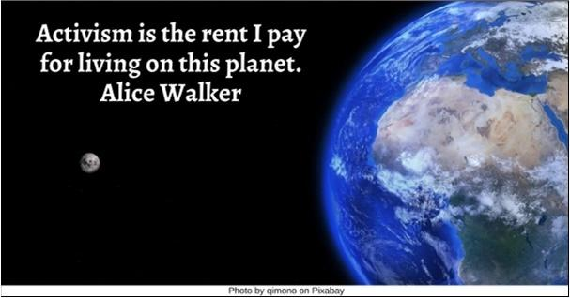

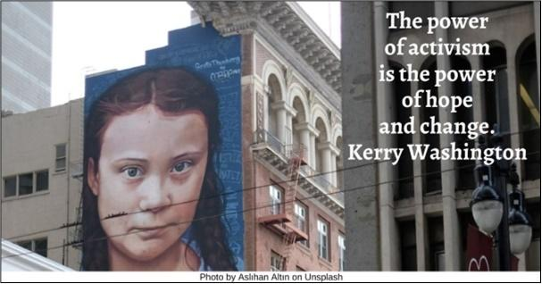

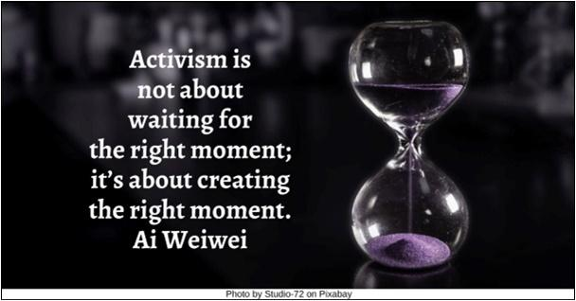

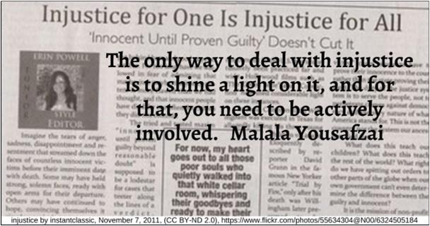



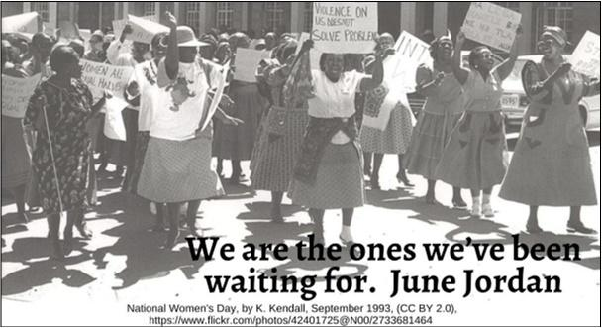

Resources for Children
2.0: Wisdom Stories
The Tapestry of Faith stories are not listed since those are easily accessible in the curricula listed at 4.0 & 5.0:
2.1: Walk of the Migrant by Rev. Anne Principe (898 words)
This can be used in worship for all ages or children’s chapel. A chime can be sounded after each stanza.
Imagine you live in a little village on a mountain.
You’ve always lived there with your family, friends.
Every day you play. Everyday everyone plays.
Every day you help out. Everyone helps out.
There are no cars in your village except for one or two every once in a while.
Imagine that his is your village. You were born here.
Imagine the rooster that runs around when you help grind the corn at the mill.
Waiting in line is fun because you and your friends play.
You’re older now. You can reach the chute to pour the corn.
Your mama sprinkles in the right amount of water to make the meal just so.
Imagine that this is your village and your life. It is all that is good and all you have known.
Imagine little by little, things start to change.
You listen to the adults talk about the trouble.
Bullies. Mean people. Stealing. Drugs. Worse.
Your friend’s father isn’t around anymore and your friend does not, or cannot, say why.
Playing is different. You have to stay so close to home.
You can’t run down the path by yourself anymore to el rio.
You try not to listen to the adults anymore. You don’t really understand.
Imagine that these are the adults of your village and they are scared.
Imagine one day when it is still dark, your mama wakes you up and says that it’s time to go.
Go where? Just go.
You’re given a bag to carry. Your mama puts it over your head and your shoulder.
Your sister says “take the clothes that fit you.”
You’re so scared but you don’t say anything because you see your sister and your little brother are scared.
Your mama is quiet and scared too.
Imagine you are leaving this home and this place you love and your grandpa and your cousins and your friends and the rooster too.
Imagine you are leaving and you have this bag around your shoulder and it’s heavy.
And you walk and are walking.
Sometimes you all hold on because you get a ride on the back of a truck with others.
Or you ride a bus. It’s a crowded and bumpy and long.
You and your mother and brother and sister take turns sleeping.
Day after day after day.
Imagine that this feels like your life now. You remember your village.
Imagine you in a new village and there is water, some food.
You don’t listen to the adults talk here either.
Your shoes have a hole. You are tired. The bag is heavy even though you have lost many things.
You are all thirsty and hungry.
More things happen, too scary to say.
And you leave again.
Imagine you leave this village where you slept with no pillow and one shared blanket.
Imagine one day you and your mother and brother and sister arrive at a border. It is so bright.
People in uniforms talk with your mama.
You sit and wait. Wait and sit.
And then you sit and wait somewhere else for a while.
There are so many people there.
Mamas. Abuelas. Children like you.
You are all shy or tired or scared. Just quiet.
Imagine you leave this place the next day.
Imagine you are in a van with your little brother, your big sister, your mama and so many others.
You look out the window and see the sky. It’s not a long ride.
You stop and get out but no one moves.
You see lots and lots of cars. Really tall buildings.
There is a house. A building.
Imagine you go inside this building, this house.
Imagine that there are so many people there.
Some people say hello to you.
They ask your mama questions.
You all walk. Your sister reads on the wall, El Comedor.
She says quietly, “comida.”
You are all at a long table. So many others.
Imagine you see a man, like your abuelo. Oraciones.
Imagine yourself, eating with your family.
The food is warm. It is good. A little different.
You and your family are taken to a room with two beds.
There are clothes are the bed, not yours, but they are for you.
You all go to a place where there is shower water, un bano.
You take a shower, one at a time.
Imagine you play in a room with other children.
Imagine this is your home for a little while, day and days.
And then it is time to go, to your primo, mama says.
As you ride in a car that someone is driving, your mama is looking at the small scrap of paper again:
Carlos. A bunch of numbers. Chicago.
You are going to a bus station.
There you sit and wait.
Imagine you are going to the place of your primo, your cousin who you do not know.
Imagine the long bus ride and how it feels like your home for a long while.
You listen -- new sounds, language, everywhere.
There are no paths, no roosters.
You miss your abuelos. Primos you know. Your friends.
Imagine finding yourself here or there, in this new land.
Imagine what it would be like for this to be your home, your life now.
To travel all this way from your little village where you were born.
What did you bring with you in your backpack?
Source: https://www.uua.org/worship/words/meditation/walk-migrant

2.2: Noelle and the Really Big Boat by Rev. Christian Schmidt
A tale of salvation, ecology, and sharing.
Characters
Narrator
Noelle
Voice in a dream
Noelle’s sisters Jane, Rain, and Elaine
Friendly farmer(s)
Ship builder(s)
Numerous animals: dogs, cats, mice, cows, horses, frogs, etc.
Act 1
(Noelle at center stage, sitting, covered in blanket and appearing asleep)
Narrator: Meet Noelle! Noelle is a young girl from a beautiful wooded valley, not far from here. Noelle had four sisters: Jane, Rain, Dayne, and Elaine. She loved to play outside, to go on long hikes in the woods, and to learn about the animals and plants and people who lived in the valley. Every afternoon, Noelle would go for long walks in the woods near her house.
Noelle: What a beautiful day it is! The sun is shining, the trees are blowing in the wind, and our river is running and splashing!
Narrator: And so it went for a long time. Until one night, she had a dream and a voice spoke to her, saying …
Voice in a Dream: Noelle! Noelle! Listen to me!
Noelle: What? Hello? Is someone there? Am I dreaming?
Voice: Yes, you’re dreaming. But I’m real, too, and I have something important to tell you. The valley will soon experience a great flood. For too long, people have been cutting down trees upriver, and now there is nothing to hold all the rainwater. Much of the soil is gone, and when the rains come this spring, a great flood will cover all the land.
Noelle: Oh no! That doesn’t sound good at all. What are we to do?
Voice: You need to build a really big boat, large enough for all the animals, and all the plants, and all your family and friends. That way, you and the valley can be saved, even though everything will flood.
Noelle: A boat? Wait, how big? To fit all the animals and plants and family and friends?
Voice: Yes. And you’ll need to grow food to feed all the people and animals, and have dirt for the plants.
Noelle: That sounds like a lot of work. I don’t think I can possibly do it myself; I don’t even know how to build a boat!
Voice: Yes, Noelle, you’ll need help from the people of the valley. Now, wake up … wake up … wake up.
Noelle: What a strange dream. Could it possibly be true?
Narrator: Noelle went out in the valley. She noticed that many trees were gone, and there was a lot of dirt showing, and it did seem like water was just flowing through places it had never flowed before. Could it be true? Could a terrible flood be coming?
(Noelle’s sisters come to one side of stage. Noelle is off stage to the other side, then comes to them as the narrator speaks)
Narrator: Noelle went to her sisters for help.
Noelle: Jane! Rain! Dayne! Elaine! Come here! So … I had a dream.
Jane: A dream?
Rain: About what?
Jane: Were there talking animals?
Elaine: Was it a good dream?
Noelle: Sort of. Well, no. But maybe. I had a dream that the river is going to flood, and water will cover all of this valley.
Jane: That doesn’t sound good at all.
Noelle: Well, no. But the dream also told me what to do about it. We have to build a really big boat, and put all the animals and plants and people of the valley in it!
Rain: All of the animals?
Elaine: All of the plants?
Rain: All of the people?
Jane: That’s gonna be a really, really, really big boat.
Noelle: Well, I suppose that two of each would probably do, but we need room for all the people, for sure. Are you all willing to help with this? I think we’ll need more than just the five of us.
Jane, Rain, Elaine: Yes! We’ll help!
Act 2
Building a boat, filling it up
(Jane, unfolding sheets of paper that look like a blueprint, which all the sisters proceed to look at)
Jane: I found these old instructions about how to build a big boat like we need!
Elaine: All these measurements are in funny words: What’s a cubit?
Jane: I don’t know, but this boat looks big enough. But how are we ever to build it? We’ll need help, that’s for sure.
Rain: We could down to the beach, where the ship builders live. They might be able to help us.
(All walk off stage left. Ship builders enter from stage right, then after a moment Noelle and sisters walk towards them)
Narrator: And so they went to the beach. Noelle explained their problem; a flood was coming and they needed to build a boat, a really big boat, so that all the people and animals and plants could be saved.
Noelle: We don’t know how to build a really big boat. We thought you might be able to help.
Ship builders: We can help! We’ll get the materials together and help you build your boat! Everyone can pitch in.
(Ship builders move to one side, begin working)
Narrator: Soon the boat started to take shape. It was larger than any boat any of them had ever seen; in fact, on the inside it looked rather like a giant church sanctuary, with benches and floors and everything; it looked a little bit like this room we’re in right now, actually! And Rain started to worry. Having a boat was one thing, but even if there was enough space for all the people and animals and plants, what would they all eat?
Rain: We’ll need lots and lots of food for everyone, won’t we?
Elaine: We can take everything from the kitchen and the pantry back at home.
Jane: I don’t think even that will be enough. We’ll have to grow a lot more food, I think, and not just in our garden.
Noelle: Maybe we can get the farmers of the valley to help us grow food!
(Sisters walk across to where farmers have come onto stage)
Narrator: And so they sought out the farmers. Elaine explained what was happening to the farmers.
Elaine: Can you help us grow food for everyone?
Friendly farmers: We can help! Come to our fields, and let’s grow food for the boat! We can grow grain and harvest nuts, we can grow vegetables and pick fruits, so that there’s food for everyone.
(Everyone goes far to the sides, then, as the narrator is speaking, Noelle goes to center and starts beckoning everyone: her sisters, the builders and farmers, and all the animals, to come to her on the boat.)
Narrator: In time, the boat was finished, and then the food was gathered in and put into the boat. When a heavy rain started, Noelle and her sisters invited everyone into the boat. It rained and rained (maybe this is a time to do that rain exercise -- you know, the snapping and clapping and stomping thing?)
Song: Rise and Shine
Act 3
The Flood
(Noelle and sisters to center stage)
Narrator: It poured for days and days. It rained and rained and rained and rained, but the land didn’t drink up the water like it used to. Instead, all the water collected in the streams and rivers, then it overflowed them, and soon the whole valley was flooded. For days and days and days, the valley stayed flooded, and the really big boat floated on the water. Everyone on the boat was safe. But as the days stretched into weeks, a problem emerged; there wasn’t enough food to last too much longer.
Noelle: We’re almost out of food! What will we do?
Rain: I don’t know! There must be something we can do to feed everyone; surely this flood will go down soon and we can return to the valley.
Elaine: Maybe we can ask everyone if they have any scraps of food left. Maybe we can all share that?
Narrator: So they asked everyone if they had anything left to share. And lo and behold, many people and animals did!
(As each group prepares to say their line, they walk forward)
Deer: We have grain we can give!
Mice: We have spices! Here, let’s share them!
Cows and goats: We have milk; all the milk you need!
Squirrels: We have nuts!
Rain: And we still have some bags of sugar!
Narrator: More and more animals and people stepped up, sharing the remnants of good they had left so that everyone could eat.
Noelle: But what we can make with all that?
Elaine: I know. We can make pudding. We’ll call it Noelle’s pudding!
Narrator: And so they made pudding. All the animals gave what they still had, and Noelle and her sisters mixed it all together, and cooked it, and soon a lovely fragrance was wafting all through the boat. And when it was ready, everyone wanted some:
Everyone: Let’s have pudding!
Noelle: When we share, there’s enough for everyone. And look, I think I see a rainbow. And, at the end of it, is that land?!
Narrator: And it was land. Just the top of a hill was showing, peeking out of the muddy waters. Soon, the waters receded and more and more land showed, and soon the boat was sitting on land again in the valley. The people and animals poured out, rejoicing, and they brought out the plants and began rebuilding their valley. Together, they worked to make it beautiful again, and they were always careful to leave plenty of trees and grasses, so that such a great flood would never come again.
Source: https://www.uua.org/worship/words/story/noelle-and-really-big-boat

2.3: The Good Samaritan by Rev. Christopher Buice (452 words)
One day a merchant was traveling on a road when he was attacked by bandits. The bandits were so cruel that they beat the merchant, stole everything he had, and left him for dead lying on the side of the road. The merchant was so badly hurt he couldn’t move or speak at all, and he could barely see through his swollen black eyes.
A long time passed, then down the road came a priest, a man of God. That priest looked good. He was wearing a fancy new robe and he was nice and clean from a recent bath. When the merchant saw the priest coming, he became excited. “Surely this priest will help me,” he thought. But when the priest saw the man lying on the side of the road, he just kept on walking and passed him right by.
After a time, the merchant saw another man coming down the road. This man was a temple helper and he looked good. He was well groomed and had a nice new haircut. He wore beautiful colorful robes and had a winning smile. Once again the merchant became hopeful. “Surely this man will help me,” he thought. But when the temple helper saw the merchant lying on the side of the road, he just kept on walking and passed him right by.
A very long time passed, and the merchant began to lose hope. “I will die here on the side of the road,” he thought. But then he saw another man walking down the road with a donkey. This man did not look too good. He was dirty and his clothes had holes in them. He did not look like he had shaved or cut his hair in a long, long time.
“This man will not help me,” thought the merchant. “He is from Samaria and Samaritans hate my people.” But when the man saw the merchant lying on the side of the road, he stopped. He was moved with compassion. The Samaritan washed and bandaged the merchant’s wounds. He put the merchant onto the back of his donkey, carried him to an inn, and took care of him. The next day, as the Samaritan prepared to leave, he gave the innkeeper money and said, “Please take care of this man. When I return, I will pay you any more money that you may spend.”
From his window in the inn, the merchant could see the Samaritan walking off into the distance. He was too weak to call out or even to speak his thanks. But ever since that time the merchant has known deep in his heart that there is a big difference between looking good and being good.
Source: https://www.uua.org/worship/words/story/good-samaritan

2.4: Higgins: a Drop With a Dream by Rev. Christopher Buice (600 words)
Once upon a time there was a drop of water named Higgins.
Higgins was no ordinary drop of water. He was a drop with a dream.
Higgins lived in a valley where it had not rained in a very long time, so all the lovely green grass was turning brown, all the beautiful flowers were wilting, and all the trees were starting to droop.
Higgins had a dream that one day the valley would be a beautiful place again. But what could he do? After all, he was only a drop of water.
One day Higgins decided to travel and tell others about his dream. All the other drops listened very politely, but no one believed that his dream would come true. “Higgins,” said one, “get your head out of the clouds. You can’t spend your whole life dreaming.”
Higgins decided that he had to do something to make his dream come true. So he began to think and think and think. One day, as he was walking by a rusty old bucket, he got an idea.
“If enough of us drops of water got together in this bucket,” Higgins thought, “there would be enough water to sprinkle on a few flowers to help them grow and become beautiful again!”
Eagerly, Higgins told everyone his great idea. But everyone thought he was being foolish. “That Higgins is nothing but a dreamer,” they said.
Higgins decided he had to do something to convince the others that he was right. So he said to them, “I don’t know about you, but I’m getting into the bucket! I hope some of you will join me. Then there might be enough water to help at least some flowers grow beautiful again.”
So Higgins ran as hard as he could, hopped way up in the air, and landed with a kerplunk in the bottom of the bucket.
And there he sat . . . JUST A DROP IN THE BUCKET.
For a long time Higgins was very lonely. It seemed like no one else was going to join him. But after awhile some of the other drops could see that the grass was dying and the flowers were wilting and the trees were drooping. They all agreed that something must be done.
Suddenly, one drop shouted, “I’m going in the bucket with Higgins!” And he leaped through the air and landed— kerplunk —in the bucket.
Then two other drops yelled, “Wait for us!” And they hopped through the air and landed in the bucket. Then ten drops jumped through the air into the bucket. Then thirty. Then fifty! And then hundreds of drops came from all around just to hop in the bucket!
Soon, the bucket was completely full of water. But there were still more drops that wanted to join, so they found another bucket and hopped in. Before long, there were two buckets of water—then three—then four—then ten—and then hundreds—and then thousands of buckets of water!
Along came a powerful breeze that blew over all the buckets, and all the water flowed together to make a mighty stream. Everywhere the water flowed, the grass turned green again and the flowers bloomed and the trees stood tall and straight once more.
All this happened because Higgins had a dream and his dream came true. Because he knew that although he was just a drop in the bucket, enough drops in the bucket make a bucketful, and when there are enough buckets with the wind behind them, then justice will roll down like waters and righteousness like a mighty stream.
Source: https://www.uua.org/worship/words/reading/higgins

2.5: Let My People Go! by Rev. Christopher Buice (876 words)
Once upon a time there was a little girl named Rosa, who loved to read her Bible. One of her favorite stories was the story of Moses, and how he helped the Hebrew slaves gain freedom.
Moses was a young man who lived in Egypt. He knew it wasn’t right for the Hebrew people to be the slaves of the Egyptian king, Pharaoh. One day, he heard a voice inside him say, “Moses, go tell Pharaoh to let my people go!”
The voice of conscience was loud and clear for Moses knew right from wrong. He also knew that when one’s conscience speaks the truth, it is the very voice of God. Moses decided that he had to go see Pharaoh and tell him to “Let my people go!”
When the Hebrew people saw Moses walking toward Pharaoh’s palace, a voice in their hearts began to sing:
“Go down, Moses,
Way down in Egypt land,
Tell ol’ Pharaoh,
Let my people go!”
But, when Moses told Pharaoh to free the Hebrew people from slavery, Pharaoh simply said, “No, no, no, no, no.”
Moses said, “Be careful, Pharaoh. All God’s children were born to be free. You may be a king but every child of God has royal blood. No one on earth was born to be a slave. You may say slavery is good but the powers of the earth and sun will rebel against that lie. The waters will turn red. The land will be filled with millions of frogs, gnats, flies, and bugs. Cows, horses, and donkeys will get sick. Hailstorms will send ice falling from the sky that will beat down everything growing in the fields. Egypt will be filled with locusts. And darkness will cover the land, turning day into night. Pharaoh, you are on the side of slavery but the universe is on the side of justice.”
And everything Moses said came to pass. Bad stuff started happening. Bugs, frogs—you name it, it happened. Sometimes Pharaoh would get sick and tired of all the misery and he would tell Moses and the Hebrew people, “You are free to go.”
But, as soon as the Hebrew people started packing their bags, Pharaoh would say, “I’ve changed my mind,” and so they would unpack their bags. Finally, Pharaoh got tired of fighting against the cause of freedom. He got sick and tired of frogs in his food and gnats in his ears. He realized that the universe was on the side of justice, and he told Moses and his people to go.
And they did go. Moses and the Hebrew people marched right out of Egypt singing:
“Ain’t gonna let no Pharaoh turn me round, turn me round, turn me round
I’m gonna keep on walking, keep on talking, marching into freedom land.”
Rosa loved to hear this story of Moses and the Hebrew slaves walking to freedom. But as she grew up and got bigger and taller, she began to look around her at the world in which she lived and she realized something . . . she realized that her people were not free.
Everywhere Rosa looked there were signs that said, “Whites Only.” Black people were not allowed in some parks, motels, lunch counters, swimming pools, and schools. They were told to sit at the back of the bus. If a white person needed the seat then the black person had to stand up and give up their seat. Rosa believed that all people should be treated fairly, and she knew in her heart that these rules were wrong.
A lot of other people agreed with her, and they agreed that they needed to challenge these unfair rules. One day Rosa got on the bus, tired after a long day’s work, and sat down. The bus went down the street a few blocks and stopped to let a lot of people who were mostly white get on board. The bus driver told some of the black passengers, including Rosa, to get up from their seats so that the white folks could sit down.
Everyone obeyed the driver—except Rosa. The bus driver told her again to get up, but she still sat in her seat. The driver threatened to call the police but Rosa still sat in her seat. Finally, the police came to take Rosa down to the station. As the other black passengers watched the police take Rosa away, there was a song in their hearts:
“Go down, Rosa, way down in Alabama,
Tell America, let my people go.”
At the police station they fined Rosa $14. But she had started something the police could not stop. The black people of Montgomery, Alabama, decided that they would not ride the buses until all people were treated fairly. This meant that the bus company would lose money. Now, in Egypt, suffering meant frogs, flies, and rivers turning red. In America, suffering means losing money. After a year of boycotting by black people, the bus company took down their “Whites Only” signs, and Rosa sat on the front seat of that bus. Rosa Parks had started a movement to lead her people from oppression toward equality.
Go down, Rosa, way down in Alabama,
Tell America, let my people go!

Source: https://www.uua.org/worship/words/story/let-my-people-go

2.6: Sister Goose and the Foxes by Faye Mogensen (373 words)
Sister Goose swam in the pond, happy as could be. Now and then, she ducked her head down to nibble a little bit here, and nibble a little bit there. She took no more than her fill of those succulent underwater plants, for she knew that the pond belonged to everyone.
Meanwhile, Brother Fox was hiding in the willows at the far end of the pond. He didn’t like to see anyone happy, least of all a goose.
Sister Goose swam along, enjoying the clear blue sky and the bright sunshine. She swam along to the willows growing at the far end of the pond. All of a sudden Brother Fox sprang right out of those willows shouting, “Trespasser! You get off my lake!”
Sister Goose shrugged up her wings and looked at Brother Fox, mystified. “Trespasser? How so? This lake does not belong to you, it belongs to us all!”
Brother Fox didn’t seem to hear her. He carried on, “You’ve been eating some of the plants in this pond. They don’t belong to you! If you don’t get out of this lake, I’m going to take you to court!”
Sister Goose was truly perplexed. She knew she hadn’t done anything wrong, but she could see by the ugly gleam in Brother Fox’s eyes that she wouldn’t be able to convince him. Instead she said, “I’m not afraid to go to court over this. At least there, justice will be served.”
And so they went to court.
But when Sister Goose arrived at the courthouse, she was very surprised. The clerks who sat just inside the doors were both foxes. Inside the courtroom, she saw that the lawyers were foxes. And the judge was a fox. And even the jurors, though some of them had red fur and some of them had brown fur and some of them had silver fur, were all foxes too.
Sister Goose was quaking as she entered the defendant’s booth. Sure enough, though her arguments were sound, the judge and the jury found her guilty. They convicted her and turned her into stew.
That is how it goes. There isn’t much justice for the likes of a goose when the folks in the courthouse are all foxes.
Source: https://www.uua.org/worship/words/story/sister-goose-and-foxes

2.7: The Shattering of the Vessels by Rev. Amy Petrie Shaw (522 words)
A Free Retelling of the Shevirat haKeilim (from the Kabbalah)
At the beginning of time, before anything else at all existed, Love was all there was, and it filled up everything in the whole universe.
But Love got bored and lonely. There was no one to be in love with. So one day Love decided to make a world.
First it took a deep breath. Can you take a deep breath? How deep? let me see! Deeper! A little deeper.
Love got all squished up taking the deepest breath ever, and was sooooo squished that it squeezed out darkness. The darkness was all around: thick and shiny and black. It was beautiful but now Love couldn’t see anything! Love waved its arms and legs around, but the darkness was everywhere.
“I have to do something about this,” said Love. It thought for a minute, and tried to think of the most wonderful beautiful warm thoughts ever. Love thought harder and harder and all of a sudden Love called out “I want light!”
And pop!
All of the warm and wonderful and beautiful thoughts exploded outward in ten different directions and shaped themselves into ten big glowing glass balls. Each ball was filled with a spinning lump of pure light and warmth. Some of the spare good thoughts that couldn’t quite fit in the glass became dust and water vapor and seeds and molecules that could form animals.
And Love said, “This is amazing. I better make something for the light to shine on.” So, it waved its arms and kicked its legs and all of the dust and water vapor and molecules that had been scattered around when the glass balls formed began to form into another huge ball, this one of dirt and water and plants and animals. Love called this the Earth.
The ten balls of light started toward the Earth, and if they had made it here in one piece, the entire planet would have been exactly the way Love wanted it. But the glass balls were too fragile to contain such strong, powerful wonderful good thoughts. They broke open and shattered, and all the good thoughts shattered and flew out like sparks and were scattered like sand, like seeds, like stars. Those sparks fell everywhere on the Earth in tiny bits instead of big clumps like Love intended.
“Oh NO!” said Love. “I’m too big. I’ll never be able to find all of those tiny sparks. I have to make one more thing.”
So, Love waved its arm and kicked its feet one last time, and people appeared on the Earth. They didn’t know it, but they were created with one job: to find these sparks, these tiny pieces of wonderful goodness, and to bring them together again in big clumps.
“When enough clumps are there, I will recreate the big glass containers to hold them, and this time I will set them down a little more carefully,” Love said.
So, all of us, from the time we are born, have a job, and that job is to help find love and more good and warm and wonderful things. If we do that, we are fixing the world.
Source: https://www.uua.org/worship/words/story/shattering-vessels

2.8: Wake Up to Injustice by Gail Forsyth-Vail (371 words)
This story was created collaboratively by several religious educators. As you prepare to share it, read the 1966 Ware Lecture “Don’t Sleep Through the Revolution,” by Dr. Martin Luther King, Jr. delivered at the Unitarian Universalist Association General Assembly in Hollywood, Florida, May 18, 1966.
There was a man named Rip van Winkle who liked to share stories and was kindly to children, but he avoided hard work or anything he thought unpleasant. One day, as the story goes, he found a nice grassy place on a mountain and he fell fast asleep. But this was no ordinary nap. Rip Van Winkle slept for over 20 years!
Twenty years!!! What do you suppose he missed [take several answers]. As a matter of fact, the most important thing that Rip Van Winkle missed was the American Revolution. When he went up the mountain, he lived in a British colony. When he came down 20 years later, he lived in the new United States.
This is an old and famous story, but would you be surprised to know that it was a favorite of the Rev. Dr. Martin Luther King? It is one he told a lot. As a matter of fact, he told it to a huge crowd of Unitarian Universalists in 1966, about 50 years ago. He talked about the Civil Rights movement, and urged all those who heard him to wake up, to not sleep through the big changes that were happening all around as Black people and their supporters worked to gain equality rights. He asked white people in particular not to be asleep and ignore injustice. He urged people to Wake Up!
Well, …a new set of leaders from the People of Color community are sending the same message Dr. King sent 50 years ago, “Wake Up! Many of the injustices- much of the unfairness- is still here. And there are some new injustices. Wake up!”
So I’m going to ask you to help me deliver this message to the Unitarian Universalists who are sitting right here in the sanctuary with us. Can you help me wake everyone up? Let’s practice saying, “Wake Up to Injustice!” [Say this with them a couple of times, and invite the children to be loud! On the third try, invite the whole congregation to join you.]
And many people who have not been paying attention, who have been “asleep” are waking up to injustice thanks to the new young leaders. We’ll talk more about waking up in our RE groups, and perhaps you may want to talk with your families about times when they have “woken up” to injustice- and perhaps are “waking up” even today.
Source: https://www.uua.org/worship/words/story/wake-injustice

2.9: Churches are Helpers by Martha Dallas (455 words)
Have you ever wondered how it came to be that churches are known as places where you can get a helping hand when you need one?
It seems to me that a key source of the charitable nature of churches goes all the way back to the time of Jesus. You see, in the society in which Jesus lived—in his time and place—things were very unfair and unjust. At that time, there were a few people at the top who were rich and powerful. And there were a bunch of people at the bottom, and these were people who were: thirsty, hungry, and poor. They were homeless and sick and disabled. And in that society, the people at the bottom were considered to be “untouchable.” It was thought that people who needed these kinds of help were so much at the bottom that if you even touched one of them, you risked becoming untouchable, yourself. There were even rules and codes to follow to make sure that the classes of society remained safely separated from each other.
And you know what Jesus thought about this? He absolutely believed it was wrong, and he rejected this unfair society with people on the bottom who were considered untouchable. He preached against it, and what’s more: he acted against it. He deliberately hung out with the untouchable people. And what’s more, he touched them. In fact, there are stories of Jesus’ healing touch—touching all these people at the bottom whom society told him not to touch. Jesus showed these people mercy, compassion, and love, and the stories of his healing touch have come down through the centuries to us.
Well, the Gospels that speak about Jesus, and the early church that emerged—took this part of Jesus’ message to heart. The church believed that if someone is thirsty, you should give them something to drink. If you find someone who’s hungry, you offer them food. If you see someone who is poor, give them some money so they can buy what they need. For people who are homeless, offer them shelter. With those who are sick, help them get medicine and treatment for their illness. And for people with disabilities, offer them a helping hand so they can get around in the world. Following Jesus’ example, this is what the church has worked to do.
Because when you see someone who has a need for help, and then you decide to offer them the kind of help that they need, well, that’s God, right there. When you offer a helping hand to someone who needs it, you allow a little bit of Heaven to shine, right here on earth. And that’s what we’re doing today.
Source: https://www.uua.org/worship/words/story/churches-are-helpers

2.10: We Are the Shepherds by Rev. Erika Hewitt (449 words)
Jesus was a teacher, long ago, of love and compassion. When Jesus spoke to his followers, it was often about how to share more, love more, and forgive more. Jesus also talked a lot about the great, unfolding mystery named Love. He called it God, the way many other people do.
Sometimes, Jesus’ followers needed help to understand his teachings, so he told stories to help them understand. We call those parables.
This is one of the parables that Jesus told his followers. It’s about a shepherd. (Someone tell me what a shepherd is.)
A shepherd is someone who cares for sheep: who makes sure their bellies are full, and they’re safe from predators—because a lot of critters would hurt sheep, if they could.
In the days when Jesus told this story, a shepherd wouldn’t have had a fancy pen, or corral, for her sheep. There was no fence to create a big space for her flock. Instead, she would have had to take her sheep out into the hills to fill their bellies.
In this parable, the shepherd didn’t have just one or four or ten sheep. She had ONE HUNDRED sheep! (Can you imagine how loud and smelly it would be if there were 100 sheep here in our sanctuary?)
At the beginning of each day, the shepherd took all one hundred sheep to the hills of green grass, and counted to make sure they were all there. At the end of the day she brought them home again, counting to make sure that all one hundred sheep had come home.
The shepherd came home one night, counted her sheep… and saw only ninety-nine instead of one-hundred. She counted again to make sure, and then again. And even though it was cold and dark, and there were critters in the hills that might hurt a shepherd, too, she left the ninety-nine sheep who were safe at home and went out to find the lost sheep who was in danger.
When Jesus told his parable to his followers, he was trying to tell them two things:
First, that the great unfolding mystery that we call Love, and that some call God, loves each of us so much that Love will always, always, go to those who are left behind or in danger.
Second, we understand ourselves to be part of the great, unfolding mystery called Love. Most of us who are Unitarian Universalist want to be like that great unfolding mystery; we want to be Love’s partner and its helper. That means we are the shepherd: when everyone else is safe, we’re called to notice the few who are in danger, and to go out into the cold and dark to be with them.
Love doesn’t rest and wait; Love—in the form of the shepherd—leaves comfort behind to be a helper.
Source: https://www.uua.org/worship/words/time-all-ages/we-are-shepherds

2.11: Something on My Face: Learning How to Be in Community by Rev. Karen G. Johnston (383 words)
Before beginning, dramatically turn your back on the congregation and children, and place a smudge on cheek. It is important that this be a smudge that is large enough for the congregation to see, but does not cover the whole face. One cheek is good. Turn around.
I need some volunteers today to be human mirrors. One at a time, I’d like you to act like you are a human mirror. You can stand near to me and say, “You have something on your face!” After you do that, I am going to respond to what you have told me. And then it will be someone else’s turn. Okay? Who will be first?
Responses:
- “Ahhhh, nope. I don’t have anything on my face.”
- “What are you talking about? You’re wrong. I’m not going to listen to you.”
- “Funny you should say that because YOU are the one who has something on YOUR face.”
- “You must be joking. I am an expert face washer. I have studied facewashing for YEARS!”
- “How dare you tell me I have something on my face! You don’t get to play with me anymore!”
- “How dare you tell me I have something on my face! I’m going to leave the game now.”
- “I have something on my face?!? What’s wrong with me? I’m going back to bed.”
- “Everybody has something on their face. So why mention it? There’s nothing we can do about it. It’s always going to be this way.”
“I have something on my face? Thank you for telling me. I’ve been washing it away, bit by bit, but I guess some of it is stickier than I thought. I really appreciate you’re letting me know. Would you be willing to help me wash my face? [provide moist wash cloths and jointly clean away that smudge...]”
When you think about being in community together and what it means to be a Unitarian Universalist, which response did you think was the best one? [Let the children answer – possible follow up questions: why do you think that? If they are unsure, you can ask, “Was it the first one, when I said that there was nothing on my face? Was it the one when I told you that you couldn’t play with me anymore?]
Sometimes, when we are building community together, it’s important to listen to what other people have to say, even if we might not want to hear it at first. But we do that because it’s part of our covenant – our promise – to each other.
There are times when we need to hear news or feedback that causes us discomfort, but in hearing it and responding to it constructively, with curiosity and humility, we can more easily go about building Beloved Community. This is especially true when it comes to feedback about how cultural privilege—along race, gender/gender identity, dis/ability, sexual orientation, class—impacts others.
This interactive story demonstrates the many ways that we respond, some unskillful, ending with one that affirms our covenant with one other.
Supplies:
Damp wash cloths or wet wipes
Substance to smudge on face that can be seen by congregation (potting soil, glitter, eye shadow, flour, etc.)
Mirror – ideal size is like a piece of notebook paper (optional)
Source: https://www.uua.org/worship/words/time-all-ages/something-my-face-learning-how-be-community

2.12: Special Glasses by Rev. Shari Woodbury (811 words)
Good morning! Do you notice anything different about me today? That’s right, I’m wearing glasses. Have you seen glasses like these before? Any idea where I might have gotten them?
They came from a 3-D movie theatre and a movie where, if you put on these special glasses, some of things you see become more full: 3-dimensional. Instead of just flat on the screen, things are more like real life, where you can reach out and touch that dinosaur or that ship on the ocean or whatever is happening in the movie.
I’m wearing these because I want to talk with you about the way different people experience life differently – a little bit like how a person might see the world differently, depending on whether or not they are wearing glasses and what kind of glasses they are wearing. (Of course, some people use other senses besides their eyes to see.)
Let’s find out what is in the Wonder Box. (shake-a-shake…) Aha! More glasses. I wonder what you notice about these glasses? [the lenses are red] And what about this pair? [the lenses are blue]
I need two volunteers: one to wear the red-tinted glasses and one to wear the blue-tinted glasses. These special glasses are big enough that you should be able to put them on even if you already wear regular glasses to help you see. [get glasses on them]
I wonder what this little critter [stuffed lamb] looks like to you? [red glasses] And how does lambie look to you? [blue glasses]
You can also touch the lamb and tell us how it feels... (For someone who doesn’t see with their eyes, but relies on touch and sound and other senses to perceive the world, this is one of the ways they could learn about lambie.)
Hmmm… how come _________ and ________ have a different perception of this lamb? Why are they giving me some different answers? Oh, because of their glasses!
How does it feel to look around at the congregation with these special glasses? Fun, silly, interesting… maybe a little strange, maybe a little confusing or uncomfortable. I guess it’s different than what you are used to.
So these glasses are a little bit like culture—ways that we understand the world around us and learn how to fit into it. We learn how to get along in life and make sense of the world through our family especially. Like how to dress, what to eat, our ideas about what is beautiful, the way we structure our day and relate to time, how we make decisions, how we express ourselves with our voices and bodies… there are so many things that you as children have been learning from the people around you, especially your families. After a while we may forget that these are things that we learned. They just seem like “the way life is.”
We learn our culture from other places too: from school, and what we call pop culture (movies, tv, music), and friends. And where else do we learn about how to make sense of the world and how to behave? Yes, here at church.
The thing about culture is, after we learn to understand the world this way, it becomes normal to us. It might even be hard to understand how someone else could have a different point of view.
Even though we might say the glasses are a bit like our culture—they help to color how we perceive the world—in real life it is much harder to “take off our glasses,” or stop understanding life through our culture, through all the ways of being that we have been taught. Let’s say you can’t really take your colorful glasses of culture off. I wonder if there is still a way that you can learn to understand better how your friend with different colored glasses is looking at life?
Well, I have some extra red transparency paper and some extra blue. Let’s see what happens when we put some red on top of your blue, ______, and some blue over your red lenses, _____. Now what does the lamb look like? Aha… purple!? Well that’s neat. You might not be able to take your glasses off and put the other one’s on, but with some effort you can get a bit closer to how the other one is seeing… and suddenly you are experiencing life in a new way! Do you like purple? (me too)
Even though we’ve been talking about seeing as a metaphor, this is about much more than what we see with our eyes, right? … and everyone, whether they literally see or not, has culture – shared ways of making meaning and learning what ways of doing things are normal. I think it’s lovely that we have more than just one culture here at Westside. It makes things more interesting! And I can learn from other people who see differently than I do.
Source: https://www.uua.org/worship/words/time-all-ages/special-glasses

2.13: The First and the Last by Martha Dallas (624 words)
Who here knows from experience that life is not fair? [Show of hands.] We know this, don’t we? Life is just not fair. And I really don’t think it ever has been. But what can we do? We generally just shrug and accept it: it’s not fair.
But there was once a man who refused to just shrug off the injustices of the world. Life was not fair, but that was not okay with him. This man was a great and wise teacher, and also a prophet. Millions of people around the world are inspired by his teachings. His name was Jesus.
And Jesus stood up and spoke out and fought for fairness and for justice. In fact he said something about this which is quite curious to me. He said, “The last shall be first, and the first shall be last.” Yes: the last shall be first… and the first shall be last. [Look perplexed… let it sink in a little.]
I’m not entirely sure what he meant by this, and my guess would be that there are several meanings this might have. But I’ve got an idea of one way we might understand it. We might understand it if we can think of what it feels like to be first, and what it feels like to be last.
So, children who are up front with me: help us understand what it feels like to be first. Maybe you have had this experience, yourself, or maybe you can imagine this. How does it feel, do you think, to be first? … to be best? … to be number one? … to come out on top? … to have the most? What do these things feel like? [Take responses and repeat them to the congregation.]
Now, what about being last? What does that feel like, do you think? How does it feel to be the worst? … to be on the bottom? … to have the least? … to have hardly anything, perhaps just crumbs or nothing? What do you think that feels like? [Take responses and repeat so all can hear.]
Thank you for sharing something with us about the feelings of being first and being last. You see, I think that fairness and justice might have a chance if the people who know what it feels like to be first – because they’ve been first so much that they’re very familiar with it – if these people can come to understand what it feels like, really feels like, to be last. And I think the world might start to become a little more fair and balanced for everyone if the people who already know too well what it feels like to be last – because they are so often the last, they so often come in at the bottom and have the least – if these people can come to know what it feels like, for a change, to actually come out on top; to be first for a change.
I can imagine that if those who are usually last and those who are usually first could share the feelings in their experiences with one another, that each might begin to experience a transformation. I believe that when we can share our feelings with one another—in a way that is safe; and when we can listen to one another in trust and with compassion – that we can begin to transform one another on the inside. When these different experiences can touch, then change can occur. And when we start to be changed on the inside, we will begin to act differently in the world; we will act more and more and more for justice.
Jesus believed that a just society was possible. It would, he taught us, create heaven, right here on earth. Heaven on earth! Now isn’t that worth living for?!
Notes: This Reflection accompanied a sermon that explored the Book of Matthew, chapter 20. The statement, “The last shall be first, and the first shall be last” is the final verse of this chapter. There are two notable points to make about it: 1) It occurs several other times, in other forms in the Christian Gospels. Jesus scholars agree that the statement, in some form, came essentially directly from Jesus. 2) It concludes the chapter in a very jarring way, ostensibly summarizing the essence of the parable, but in actuality being misused. In this setting, its risks confusing the reader, because at best, Jesus’ moral teachings are only implied. Scholars tend to believe the verse was added to the parable at a later time.
Source: https://www.uua.org/worship/words/story/first-and-last

2.14: Soil Layers of Oppression by mandi Huizenga (561 words)
Preparation: In a glass vase, place a layer of dirt. Prepare colored sand to pour on top (each color corresponding to a different oppression.) Have a spoon ready.
Begin by asking children what is in the vase and what it means to have rich, healthy soil.
For thousands of years, Native Americans have lived on this land. And then Europeans came. The Europeans thought they had a better way of doing things. And when they came to the Americas, they brought these different ways.
First, they came and took the land; they became owners of the land rather than sharing it. They took over and controlled the land and the native peoples and many of them died or were hurt or were forced to live in ways that were very different from what they were used to. There is a really big word that is used to describe the controlling of land and the people who live on it: colonization. They added Colonization to the soil.
Pour in sand.
These Europeans also brought a new way of being together. This way of being together would not allow women to own property, have jobs, or even vote. This way of being together is called Patriarchy. Patriarchy is a fancy word for the idea that men are better than women. They added Patriarchy to the soil.
Pour in sand.
Then, these Europeans decided that while the land was rich and grew a lot of things, they could grow even richer themselves by forcing others to work for them. So the Europeans brought Slavery to America. They forced people from Africa onto ships and brought them across the ocean. They made them work the land without money. They added Slavery to the soil.
Pour in sand.
Overtime, other things were added to the soil as well. These other things include:
Not letting people love who they want
Not helping people who are disabled
Making it difficult for poor people to earn money
Making voting difficult for poor people and people of color
Putting people in prison for little problems
Polluting our soil, air, and water
Pour in sand. Of other colors.
The word I use for all these things is supremacy. That is a big word that means a small group of people control many different things in our world and make it difficult for people who are not like this small group to live differently.
Now some of these things that were added to the soil were changed over a long time. Women are now allowed to vote and hold jobs. There is no longer slavery.
Take out a bit of the colored sand.
But these things still exist just in different ways. In many states, women still cannot do what they want to with their bodies. Slavery as it existed two hundred or four hundred years ago no longer exists, but has taken on newer forms as people are still paid poorly or not at all in this country. Rich people are getting richer and poor people are getting poorer.
All of these things are still in our soil. (Gesture to the colored sand.)
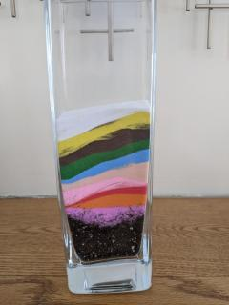
How can good food and other good things grow with these bad things on our soil? How can we be healthy if we can’t grow good food or have good things in our lives?
What can we do to get to the good soil?
This is hard work. It is hard because the sand is small and it gets into everything. But if we want to be healthy and live in a world where everyone is cared for, we need to do this work of removing the sand. The best way to do this, is to do this together so we can plant the seeds of love and justice in the world.
a tall glass vase, rectangular, with a layer of soil at the bottom and about 8 striations of colored sand poured over it.
What mandi’s vase of sand looked like after she led this time for all ages.
Source: https://www.uua.org/worship/words/time-all-ages/soil-layers-oppression

3.0: Children’s Books
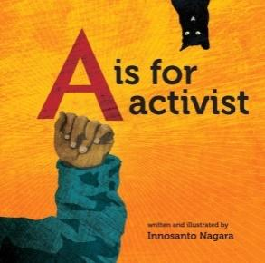
3.1: A is for Activist (Board Book) by Innosanto Nagara (2013)
“A is for Activist is an ABC board book written and illustrated for the next generation of progressives: families who want their kids to grow up in a space that is unapologetic about activism, environmental justice, civil rights, LGBTQ rights, and everything else that activists believe in and fight for.
“The alliteration, rhyming, and vibrant illustrations make the book exciting for children, while the issues it brings up resonate with their parents’ values of community, equality, and justice. This engaging little book carries huge messages as it inspires hope for the future, and calls children to action while teaching them a love for books.”
Video Link: https://www.youtube.com/watch?v=ZIdCCKDGvF4 (7:18)

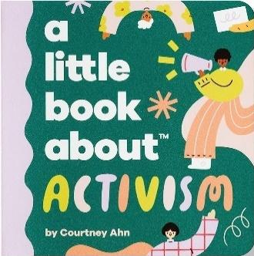
3.2: A Little Book About Activism by Courtney Ahn (2021)
“A little book with a big goal! This book aims to give kids the building blocks to develop strong principles of care, empathy, and community. Because you’re never too young to make a difference!”
Video Link: https://www.youtube.com/watch?v=C4K37d8QrsA (2:31)

3.3: Enough! 20 Protesters Who Changed America by Emily Easton (Author) and Ziyue Chen (Illustrator) (2018)
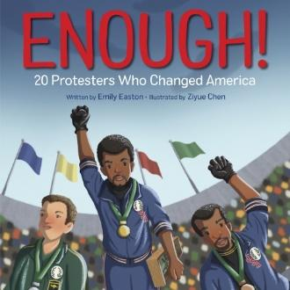
“America has been molded and shaped by those who have taken a stand and said they have had enough. In this dynamic picture book, stand alongside the nation’s most iconic civil and human rights leaders, whose brave actions rewrote history.
“Join Samuel Adams as he masterminds the Boston Tea Party, Ruby Bridges on her march to school, Colin Kaepernick as he takes a knee for Black lives, and the multitude of other American activists whose peaceful protests have ushered in lasting change.
Video Link: https://www.youtube.com/watch?v=77nwKme8404 (3:30)

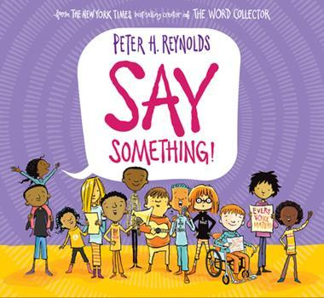
3.4: Say Something! by Peter H. Reynolds (2019)
“‘The world needs your voice. If you have a brilliant idea... say something! If you see an injustice... say something!’
“In this empowering new picture book, beloved author Peter H. Reynolds explores the many ways that a single voice can make a difference. Each of us, each and every day, have the chance to say something: with our actions, our words, and our voices. Perfect for kid activists everywhere, this timely story reminds readers of the undeniable importance and power of their voice.”
Video Link: https://www.youtube.com/watch?v=U_-rP-oaRpY (4:48)

3.5: My Voice Is a Trumpet by Jimmie Allen, author and Cathy Ann Johnson, illustrator (2021)
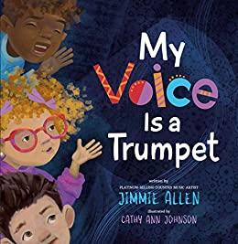
“From voices tall as a tree, to voices small as a bee, all it takes is confidence and a belief in the goodness of others to change the world. Coming at a time when issues of social justice are at the forefront of our society, this is the perfect book to teach children in and out of the classroom that they’re not too young to express what they believe in and that all voices are valuable.”
Video Link: https://www.youtube.com/watch?v=KVVEwvTeJ4I (2:43)

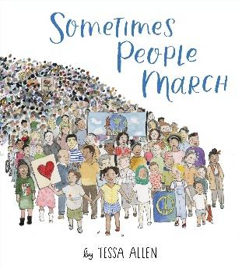
3.6: Sometimes People March by Tessa Allen (2020)
“Simple, direct statements are paired with watercolor illustrations to highlight some of the rallying causes for organized marches throughout the history of the United States.”
Video Link: https://www.youtube.com/watch?v=ZaqdV6GJT8g (4:23)
Teaching Resource: https://www.learningtogive.org/resources/sometimes-people-march-literature-guide

3.7: She Persisted: 13 American Women Who Changed the World by Chelsea Clinton, author, and Alexandra Boiger, illustrator (2017)
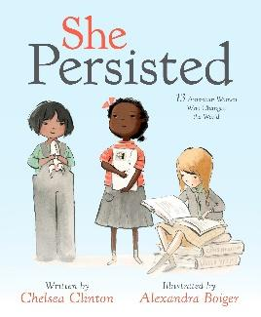
“Throughout United States history, there have always been women who have spoken out for what’s right, even when they have to fight to be heard. In this book, Chelsea Clinton celebrates thirteen American women who helped shape our country through their tenacity, sometimes through speaking out, sometimes by staying seated, sometimes by captivating an audience. They all certainly persisted. …
“This book features: Harriet Tubman, Helen Keller, Clara Lemlich, Nellie Bly, Virginia Apgar, Maria Tallchief, Claudette Colvin, Ruby Bridges, Margaret Chase Smith, Sally Ride, Florence Griffith Joyner, Oprah Winfrey, Sonia Sotomayor—and one special cameo.”
Video Link: https://www.youtube.com/watch?v=DFJkBSbJe18 (10:04)

3.8: She Persisted Around the World: 13 Women Who Changed History by Chelsea Clinton, author, and Alexandra Boiger, illustrator (2018)
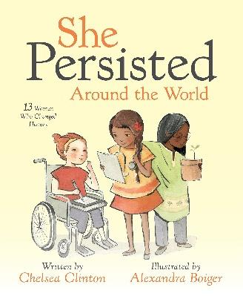
“Women around the world have long dreamed big, even when they’ve been told their dreams didn’t matter. They’ve spoken out, risen up and fought for what’s right, even when they’ve been told to be quiet. Whether in science, the arts, sports or activism, women and girls throughout history have been determined to break barriers and change the status quo. They haven’t let anyone get in their way and have helped us better understand our world and what’s possible. In this companion book to She Persisted: 13 American Women Who Changed the World, Chelsea Clinton introduces readers to a group of thirteen incredible women who have shaped history all across the globe. …
This book features: Marie Curie, Sor Juana Ines de la Cruz, Viola Desmond, Sissi Lima do Amor, Leymah Gbowee, Caroline Herschel, Wangari Maathai, Aisha Rateb, J.K. Rowling, Kate Sheppard, Yuan Yuan Tan, Mary Verghese and Malala Yousafzai.”
Video Link: https://www.youtube.com/watch?v=-HkNlomq32s (12:21)

3.9: Elizabeth Started All the Trouble by Doreen Rappaport, author and Matt Faulkner, illustrator (2016)
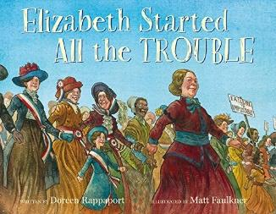
“When real suffragette Elizabeth Cady Stanton and her friend are denied entry to an important meeting just because they are women, it sets a series of events into motion. From the historic Seneca Falls Convention to Wyoming becoming the first state where women could vote, Elizabeth Started All the Trouble skips in and out through the ages of fighting for women’s rights, bringing readers right up to present day.
…Other activists and influential people including Abigail Adams, Lucretia Mott, Sojourner Truth, Susan B. Anthony, and Amelia Bloomer are mentioned. This gives readers a deeper understanding of the fight.”
Video Link: https://www.youtube.com/watch?v=NdmpgjCE8xs (19:01)

3.10: Friends for Freedom: The Story of Susan B. Anthony & Frederick Douglass by Suzanne Slade (Author) and Nicole Tadgell (Illustrator) (2014)
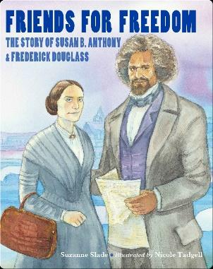
“No one thought Susan B. Anthony and Frederick Douglass would ever become friends. The former slave and the outspoken woman came from two different worlds. But they shared deep-seated beliefs in equality and the need to fight for it. Despite naysayers, hecklers, arsonists, and even their own disagreements, Susan and Frederick remained fast friends and worked together to change America.
“This little-known story introduces young readers to two momentous personalities in American history and to their fiery passion for human rights and equality.”
Video Link: https://www.youtube.com/watch?v=DBA6EcpfmsM (9:18)

3.11: Brave Girl: Clara and the Shirtwaist Makers’ Strike of 1909 by Michelle Markel, author and Melissa Sweet, illustrator (2013)
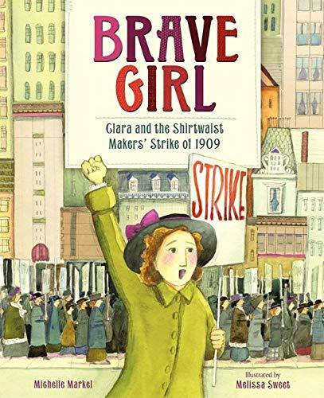
“The true story of the young immigrant who led the largest strike of women workers in U.S. history. This picture book biography about the plight of immigrants in America in the early 1900s and the timeless fight for equality and justice should not be missed.
“When Clara arrived in America [from Ukraine], she couldn’t speak English. She didn’t know that young women had to go to work, that they traded an education for long hours of labor, that she was expected to grow up fast.
“But that didn’t stop Clara. She went to night school, spent hours studying English, and helped support her family by sewing in a shirtwaist factory.
“Clara never quit, and she never accepted that girls should be treated poorly and paid little. Fed up with the mistreatment of her fellow laborers, Clara led the largest walkout of women workers the country had seen.
“From her short time in America, Clara learned that everyone deserved a fair chance. That you had to stand together and fight for what you wanted. And, most importantly, that you could do anything you put your mind to.”
Video Link: https://www.youtube.com/watch?v=RxbHVOUuSZI (10:29)

3.12: On Our Way to Oyster Bay: Mother Jones and Her March for Children’s Rights by Monica Kulling (Author) and Felicita Sala (Illustrator) 2016
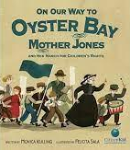
“Though eight-year-old Aidan and his friend Gussie want to go to school, like many other children in 1903, they work twelve hours, six days a week, at a cotton mill in Pennsylvania instead. So, when the millworkers decide to go on strike, the two friends join the picket line. Maybe now life will change for them. But when a famous labor reformer named Mother Jones comes to hear of the millworkers’ demands, she tells them they need to do more than just strike. “Troubled by all she had seen, Mother Jones wanted to end child labor. But what could she do? Why, organize a children’s march and bring the message right to President Theodore Roosevelt at his summer home in Oyster Bay, of course!”
Video Link: https://www.youtube.com/watch?v=Hfn2jcfZxGg (7:33)

3.13: Child of the Civil Rights Movement by Paula Young Shelton, (Author) and Raul Colón (Illustrator) (2009)
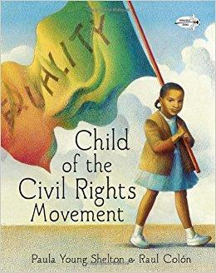
“Paula Young Shelton, daughter of Civil Rights activist Andrew Young, brings a child’s unique perspective to an important chapter in America’s history. Paula grew up in the deep south, in a world where whites had and blacks did not. With an activist father and a community of leaders surrounding her, including Uncle Martin (Martin Luther King), Paula watched and listened to the struggles, eventually joining with her family—and thousands of others—in the historic march from Selma to Montgomery.”
Video Link: https://www.youtube.com/watch?v=6gFpQOTcjV4 (11:48)

3.14: The Story of Ruby Bridges by Robert Coles (Author) and George Ford (Illustrator) (1995)
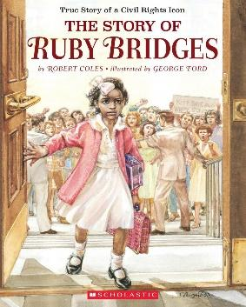
“The inspirational true story of Ruby Bridges. The year is 1960, and six-year-old Ruby Bridges and her family have recently moved from Mississippi to New Orleans in search of a better life. When a judge orders Ruby to attend first grade at William Frantz Elementary, an all-white school, Ruby must face angry mobs of parents who refuse to send their children to school with her.”
Video Link: https://www.youtube.com/watch?v=vIBr7NsHAJw (9:30)

3.15: Voice of Freedom: Fannie Lou Hamer: The Spirit of the Civil Rights Movement by Carole Boston Weatherford (Author) and Ekua Holmes (Illustrator) (2015)
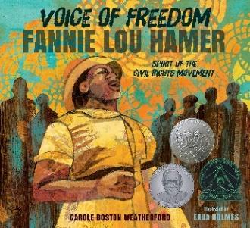
“Despite fierce prejudice and abuse, even being beaten to within an inch of her life, Fannie Lou Hamer was a champion of civil rights from the 1950s until her death in 1977. Integral to the Freedom Summer of 1964, Ms. Hamer gave a speech at the Democratic National Convention that, despite President Johnson’s interference, aired on national TV news and spurred the nation to support the Freedom Democrats. Featuring vibrant mixed-media art full of intricate detail, Voice of Freedom celebrates Fannie Lou Hamer’s life and legacy with a message of hope, determination, and strength.”
Video Link: https://www.youtube.com/watch?v=MF-4xKmHiSo (24:32)

3.16: Walking toward Peace: The True Story of a Brave Woman Called Peace Pilgrim by Kathleen Krull (Author) and Annie Bowler (Illustrator) (2021)
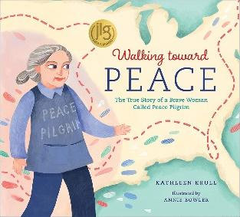
“She gave up everything: her home, her possessions, even her real name. She called herself Peace Pilgrim, put on her sneakers, and started off on her quest to walk thousands of miles all around America. Step by step, mile after mile, Peace Pilgrim traveled tirelessly, inviting everyone she met to consider a world where each person and each nation chooses peace.
“This true story about a little-known woman who sacrificed everything for her convictions inspires us to step out for what we believe in, gathering others to join us along the way.”
Video Link: https://www.youtube.com/watch?v=HE5BYV9z6-s (10:42)

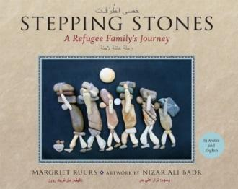
3.17: Stepping Stones by Margriet Ruurs (Author) and Nizar Ali Badr (Illustrator) (2016)
“This unique picture book was inspired by the stone artwork of Syrian artist Nizar Ali Badr, discovered by chance by Canadian children’s writer Margriet Ruurs. The author was immediately impressed by the strong narrative quality of Mr. Badr’s work, and, using many of Mr. Badr’s already-created pieces, she set out to create a story about the Syrian refugee crisis. Stepping Stones tells the story of Rama and her family, who are forced to flee their once-peaceful village to escape the ravages of the civil war raging ever closer to their home. With only what they can carry on their backs, Rama and her mother, father, grandfather and brother, Sami, set out to walk to freedom in Europe. Nizar Ali Badr’s stunning stone images illustrate the story.”
Video Link: https://www.youtube.com/watch?v=bI5TuJCOTV0 (7:27)
Background about book
Video Link: https://www.youtube.com/watch?v=QAo0mWStsIw (2:11)

Syrian creative havens: Nizar Ali Badr

Video Link: https://www.youtube.com/watch?v=UmoPKZHdVVo&t=61s (2:46)

3.18: Side by Side: The Story of Dolores Huerta and Cesar Chavez/ Lado a Lado: The La Historia de Dolores Huerta y Cesar Chavez by Monica Brown (Author) and Joe Cepeda (Illustrator) 2010
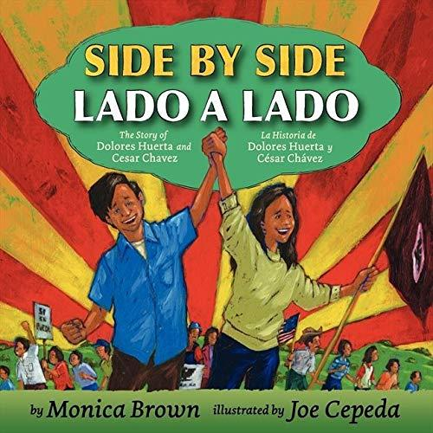
“Every day, thousands of farmworkers harvested the food that ended up on kitchen tables all over the country. But at the end of the day, when the workers sat down to eat, there were only beans on their own tables. Then Dolores Huerta and Cesar Chavez teamed up. Together they motivated the workers to fight for their rights and, in the process, changed history.”
Video Link: https://www.youtube.com/watch?v=CLODlMZio6o (12:42)

3.19: Lola Out Loud: Inspired by the Childhood of Activist Dolores Huerta by Jennifer Torres (Author) and Sara Palacios (Illustrator) (2022)
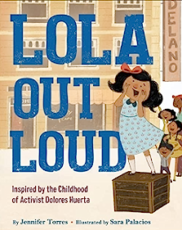
“Her grandpa calls her ‘Lolita Siete Lenguas’—Little Lola, Seven Tongues, all fighting to be heard. Lola is trying not to make so much noise, but when she witnesses injustices in her own neighborhood, she knows she can’t keep quiet. Can Lola find a way to use her voice for change? ¡Sí, se puede!
“Inspired by the real-life civil rights activist and labor leader Dolores Huerta, Lola Out Loud is a warm and rollicking picture book that reminds us that sometimes one strong voice is just what we need.”
Video Link: https://www.youtube.com/watch?v=zwbEPJ6ogJ0 (8:27)

3.20: The Power of Her Pen: The Story of Groundbreaking Journalist Ethel L. Payne by Lesa Cline-Ransome (Author) and John Parra (Illustrator) (2020)
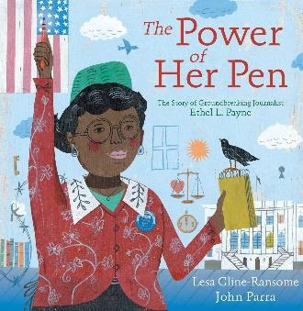
“Ethel Payne always had an ear for stories. Seeking truth, justice, and equality, Ethel followed stories from her school newspaper in Chicago to Japan during World War II. It even led her to the White House briefing room, where she broke barriers as the only black female journalist. Ethel wasn’t afraid to ask the tough questions of presidents, elected officials, or anyone else in charge, earning her the title, ‘First Lady of the Black Press.’”
“Fearless and determined, Ethel Payne shined a light on the darkest moments in history, and her ear for stories sought answers to the questions that mattered most in the fight for Civil Rights.”
Video Link: https://www.youtube.com/watch?v=P_R5lx5ktb4&t=102s (9:48)

3.21: Equality’s Call: The Story of Voting Rights in America by Deborah Diesen (Author) and Magdalena Mora (Illustrator) (2020)
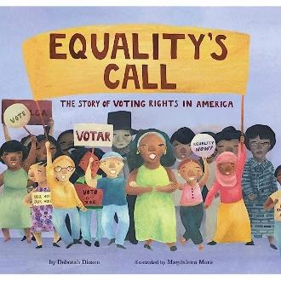
“The founders of the United States declared that consent of the governed was a key part of their plan for the new nation. But for many years, only white men of means were allowed to vote. This unflinching and inspiring history of voting rights looks back at the activists who answered equality’s call, working tirelessly to secure the right for all to vote, and it also looks forward to the future and the work that still needs to be done.”
Video Link: https://www.youtube.com/watch?v=CE9z-Qswg44 (5:43)

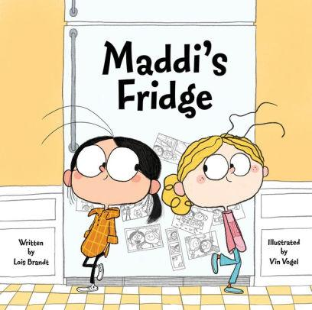
3.22: Maddi’s Fridge by Lois Brandt (Author) and Vin Vogel (Illustrator) (2014)
“Best friends Sofia and Maddi live in the same neighborhood, go to the same school, and play in the same park, but while Sofia’s fridge at home is full of nutritious food, the fridge at Maddi’s house is empty. Sofia learns that Maddi’s family doesn’t have enough money to fill their fridge and promises Maddi she’ll keep this discovery a secret. But because Sofia wants to help her friend, she’s faced with a difficult decision: to keep her promise or tell her parents about Maddi’s empty fridge. Filled with colorful artwork, this storybook addresses issues of poverty with honesty and sensitivity while instilling important lessons in friendship, empathy, trust, and helping others. A call-to-action section, with six effective ways for children to help fight hunger and information on antihunger groups, is also included.”
Video Link: https://www.youtube.com/watch?v=nuLk_5xBiAw (9:42)
Video Link: https://www.youtube.com/watch?v=To07TjBnrNY (12:41) (animated)

3.23: Home (a story about homelessness) by Tonya Lippert (Author) and Andrea Stegmaier (Illustrator) (2022)
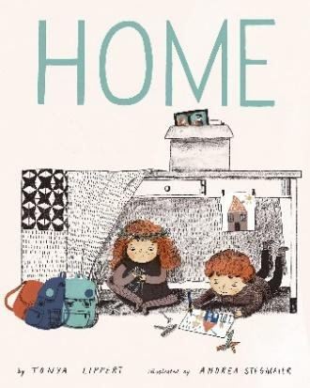
“This lyrical story is timely and thoughtful, depicting the life of two children thrust into homelessness and uncertain housing situations as they move out of their house, to a motel, to a shelter, and finally another more permanent home. Throughout, the duo is challenged by uncomfortable new places and inquiries from strangers, but ultimately, never lose their optimism or determination. They have each other, no matter at home, nowhere, anywhere, or somewhere—always. Includes a poignant Reader’s Note on how homelessness affects children and what we can do to help.”
Video Link: https://www.youtube.com/watch?v=JG2G5ijUBpY (7:20)

3.24: And Tango Makes Three by Justin Richardson and Peter Parnell, authors and Henry Cole, illustrator (2005)
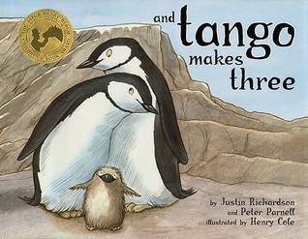
And Tango Makes Three is the bestselling, heartwarming true story of two penguins who create a nontraditional family.
At the penguin house at the Central Park Zoo, two penguins named Roy and Silo were a little bit different from the others. But their desire for a family was the same. And with the help of a kindly zookeeper, Roy and Silo get the chance to welcome a baby penguin of their very own.
Selected as an ALA Notable Children’s Book Nominee and a Lambda Literary Award Finalist, “this joyful story about the meaning of family is a must for any library”
Video Link: https://www.youtube.com/watch?v=WyPjUa908hM&t=154s (7:43)

3.25: Malala’s Magic Pencil by Malala Yousafzai, author and Kerascoët, illustrator (2017)
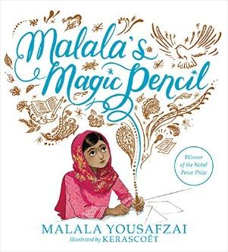
“As a child in Pakistan, Malala made a wish for a magic pencil. She would use it to make everyone happy, to erase the smell of garbage from her city, to sleep an extra hour in the morning. But as she grew older, Malala saw that there were more important things to wish for. She saw a
world that needed fixing. And even if she never found a magic pencil, Malala realized that she could still work hard every day to make her wishes come true.”
Video Link: https://www.youtube.com/watch?v=zVgtqDDXWVg (10:09)

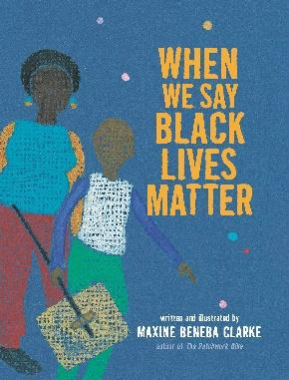
3.26: When We Say Black Lives Matter by Maxine Beneba Clarke (2021)
“In this joyful exploration of the Black Lives Matter motto, a loving narrator relays to a young Black child the strength and resonance behind the words. In family life, through school and beyond, the refrains echo and gain in power, among vignettes of protests and scenes of ancestors creating music on djembe drums. With deeply saturated illustrations rendered in jewel tones, Maxine Beneba Clarke offers a gorgeous, moving, and essential picture book.”
Video Link: https://www.youtube.com/watch?v=Zxsd5WtOktA (3:10)

3.27: Not My Idea: A Book About Whiteness (Ordinary Terrible Things) by Anastasia Higginbotham (2018)
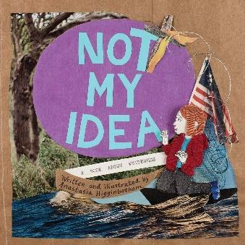
“Not My Idea: A Book About Whiteness is a picture book about racism and racial justice, inviting white children and parents to become curious about racism, accept that it’s real, and cultivate justice.”
Video Link: https://www.youtube.com/watch?v=kA5Az6c5iUs (9:30)

3.28: Something Happened in Our Town: A Child’s Story About Racial Injustice by Marianne Celano, Marietta Collins, and Ann Hazzard (Authors) and Jennifer Zivoin (Illustrator) (2019)
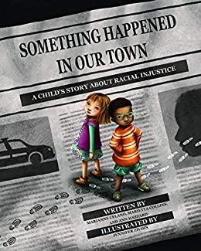
“Something Happened in Our Town follows two families — one White, one Black — as they discuss a police shooting of a Black man in their community. The story aims to answer children’s questions about such traumatic events, and to help children identify and counter racial injustice in their own lives.
“Includes an extensive Note to Parents and Caregivers with guidelines for discussing race and racism with children, child-friendly definitions, and sample dialogues.”
Video Link: https://www.youtube.com/watch?v=Pi7_Ps6Jf7Y (6:43)

3.29: Something Happened in Our Park: Standing Together After Gun Violence by Ann Hazzard, Marianne Celano, and Marietta Collins (Authors) and Keith Henry Brown (Illustrator) (2021)
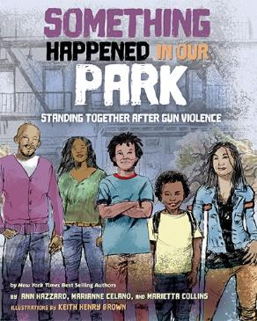
“When Miles’s cousin, Keisha, is injured in a shooting, he realizes people can work together to reduce the likelihood of violence in their community. With help from friends and family, Miles learns to use his imagination and creativity to help him cope with his fears. This book can help provide parents with helpful messages of reassurance and empowerment. Includes an extensive Note to Parents and Caregivers with guidelines for discussing community gun violence with children, and sample dialogues.”
Video Link: https://www.youtube.com/watch?v=iuw0TlB0tOs (8:03)

3.30: A All the Way to the Top: How One Girl’s Fight for Americans with Disabilities Changed Everything by Annette Bay Pimentel (Author) and Nabi Ali (Illustrator) (2020)
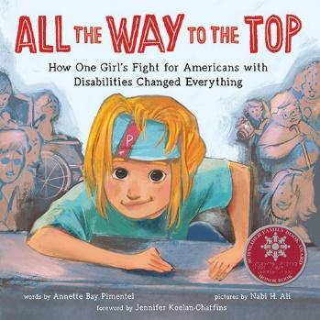
“This is the story of a little girl who just wanted to go, even when others tried to stop her.
“Jennifer Keelan was determined to make a change―even if she was just a kid. She never thought her wheelchair could slow her down, but the way the world around her was built made it hard to do even simple things. Like going to school, or eating lunch in the cafeteria.
“Jennifer knew that everyone deserves a voice! Then the Americans with Disabilities Act, a law that would make public spaces much more accessible to people with disabilities, was proposed to Congress. And to make sure it passed; Jennifer went to the steps of the Capitol building in Washington DC to convince them.
“And, without her wheelchair, she climbed.
“ALL THE WAY TO THE TOP!”
Video Link: https://www.youtube.com/watch?v=FmM8Ns1DOb0 (7:17)

3.31: Greta and the Giants: inspired by Greta Thunberg’s stand to save the world by Zoë Tucker (Author) and Zoe Persico (Illustrator) 2019
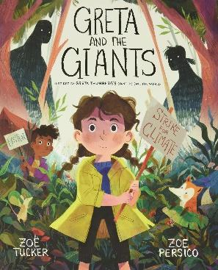
“This inspiring picture book retells the story of Nobel Peace Prize nominee Greta Thunberg—the Swedish teenager who has led a global movement to raise awareness about the world’s climate crisis—using allegory to make this important topic accessible to young children.
“Greta is a little girl who lives in a beautiful forest threatened by Giants. When the Giants first came to the forest, they chopped down trees to make houses. Then they chopped down more trees and made even bigger homes. The houses grew into towns and the towns grew into cities, until now there is hardly any forest left. Greta knows she has to help the animals who live in the forest, but how? Luckily, Greta has an idea…”
Video Link: https://www.youtube.com/watch?v=pTKDC_Nxdqc (4:51)

3.32: The World Needs More Purple People by Kristen Bell & Benjamin Hart (Authors) and Daniel Wiseman (Illustrator) (2020)
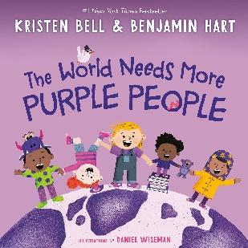
“What is a purple person? Great question. I mean, really great! Because purple people always ask really great questions. They bring their family, friends, and communities together, and they speak up for what’s right. They are kind and hardworking, and they love to laugh (especially at Grandpa’s funny noises)! A purple person is an everyday superhero! How do you become one? That’s the fun part! Penny Purple will lead you through the steps. Get ready to be silly, exercise your curiosity, use your voice, and be inspired.
“Looking to reach beyond the political divide of red and blue, Kristen Bell and Benjamin Hart have created a hilarious and joyous read-aloud that offers a wonderful message about embracing the things that bring us together as humans. This book will inspire a whole generation to paint the world purple!”
Video Link: https://www.youtube.com/watch?v=LviYLYVRScw (5:34)

3.33: Crossing Bok Chitto: A Choctaw Tale of Friendship & Freedom by Tim Tingle,
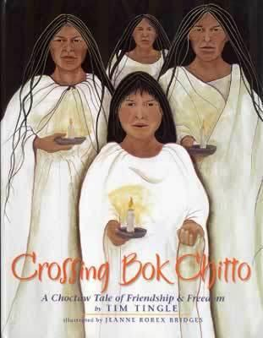
author and Jeanne Rorex Bridges, illustrator (2006)
“There is a river called Bok Chitto that cuts through Mississippi. In the days before the War Between the States, in the days before the Trail of Tears, Bok Chitto was a boundary. On one side of the river lived the Choctaws. On the other side lived the plantation owners and their slaves. If a slave escaped and made his way across Bok Chitto, the slave was free.
“Martha Tom, a young Choctaw girl, knows better than to cross Bok Chitto, but one day—in search of blackberries—she disobeys her mother and finds herself on the other side. A tall slave discovers Martha Tom. A friendship begins between Martha Tom and the slave’s family, most particularly his young son, Little Mo. Soon afterwards, Little Mo’s mother finds out that she is going to be sold. The situation seems hopeless, except that Martha Tom teaches Little Mo’s family how to walk on water to their freedom.”
Video Link: https://www.youtube.com/watch?v=GyyDCVIwrF4 (18:46)

3.34: Separate Is Never Equal: Sylvia Mendez and Her Family’s Fight for Desegregation by Duncan Tonatiuh (2014)
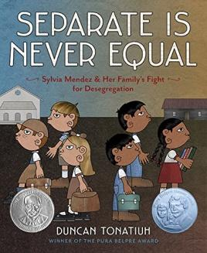
“Almost 10 years before Brown vs. Board of Education, Sylvia Mendez and her parents helped end school segregation in California. An American citizen of Mexican and Puerto Rican heritage who spoke and wrote perfect English, Mendez was denied enrollment to a “Whites only” school. Her parents took action by organizing the Hispanic community and filing a lawsuit in federal district court. Their success eventually brought an end to the era of segregated education in California.”
Video Link: https://www.youtube.com/watch?v=gW6jzzIwAQo (14:54)

3.35: Granddaddy’s Turn: A Journey to the Ballot Box by Michael S. Bandy & Eric Stein, authors and James E. Ransome, illustrator (2015)
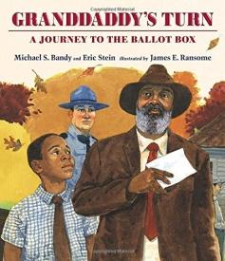
“Life on the farm with Granddaddy is full of hard work, but despite all the chores, Granddaddy always makes time for play, especially fishing trips. Even when there isn’t a bite to catch, he reminds young Michael that it takes patience to get what’s coming to you. One morning, when Granddaddy heads into town in his fancy suit, Michael knows that something very special must be happening—and sure enough, everyone is lined up at the town hall! For the very first time, Granddaddy is allowed to vote, and he couldn’t be more proud. But can Michael be patient when it seems that justice just can’t come soon enough? This powerful and touching true-life story shares one boy’s perspective of growing up in the segregated South, while beautiful illustrations depict the rural setting in tender detail.”
Video Link: https://www.youtube.com/watch?v=2dR8LdmNdBs (7:18)

3.36: Aani & the Tree Huggers by Jeannine Atkins, author and Venantius J. Pinto, illustrator (1995)
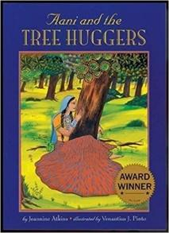
“Horrified by the city people who have come to cut down their beloved forest homeland, Aani and other members of her village try to make them understand how important the trees are, and a single act of bravery helps save the forest.”
Video Link: https://www.youtube.com/watch?v=BnWD1iC7Lqw (10:54)
“The text is based on actual events known as the Chipko Andolan (Hug the Tree Movement), which took place in northern India in the 1970s. This movement did much to preserve local forests; today, councils meet within most villages to decide how many trees can be cut without endangering the land and those who live there, and also, new trees are planted each spring.”

3.37: What Can a Citizen Do? by Dave Eggers (Author) and Shawn Harris (Illustrator) (2018)
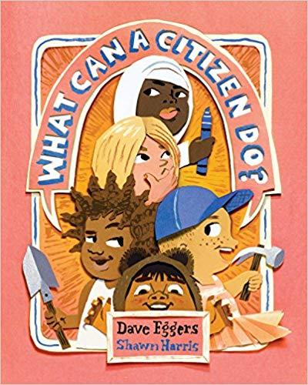
“Obligatory reading for future informed citizens.” —The New York Times “[This] charming book provides examples and sends the message that citizens aren’t born but are made by actions taken to help others and the world they live in.” –The Washington Post “It’s a light-hearted but empowering look at the difference a citizen, especially kid citizens, can make in a community.” “We can see children making laws, and then changing them because some people don’t like them. They right wrongs; they ‘care and care.’ I especially liked the line ‘A citizen’s not what you are – a citizen is what you do.’ (Recommended for ages 3 – 7)
Video Link: https://www.youtube.com/watch?v=FuWm6IdVNQ4 (3:30)

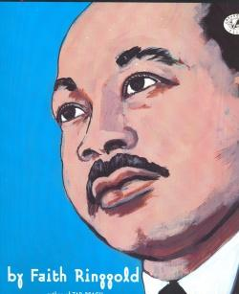
3.38: My Dream of Martin Luther King by Faith Ringgold (1995)
The acclaimed author/illustrator Faith Ringgold “recounts her unique vision of Martin Luther King, Jr. by describing a dream she had about the great civil rights leader. The dream includes scenes of King’s childhood and the major events of his life, from the boycott of the segregated buses to his ‘I Have a Dream’ speech to his assassination. Illustrated in Ringgold’s signature folk-art style, the text includes the author’s own personal vision, in which she imagines the people of the world gathering in King’s memory to trade prejudice, fear, and hate for hope, peace, and love.”
Video Link: https://www.youtube.com/watch?v=pnwj28gFKU0 (10:05)
Teaching Resource: https://www.teachingchildrenphilosophy.org/BookModule/MyDreamOfMartinLutherKing

3.39: Lillian’s Right to Vote: A Celebration of the Voting Rights Act of 1965 by Jonah Winter, author and Shane W. Evans, illustrator (2015)
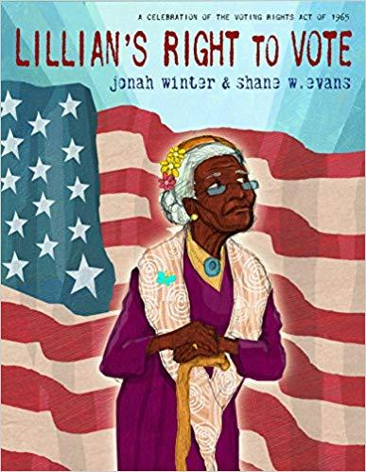
“An elderly African American woman, en route to vote, remembers her family’s tumultuous voting history in this picture book publishing in time for the fiftieth anniversary of the Voting Rights Act of 1965.
“As Lillian, a one-hundred-year-old African American woman, makes a ‘long haul up a steep hill’ to her polling place, she sees more than trees and sky—she sees her family’s history. She sees the passage of the Fifteenth Amendment and her great-grandfather voting for the first time. She sees her parents trying to register to vote. And she sees herself marching in a protest from Selma to Montgomery.”
Video Link: https://www.youtube.com/watch?time_continue=2&v=hcHqt68RdHM (12:10)

3.40: If You’re Going to a March by Martha Freeman, author and Violet Kim, illustrator (2018)
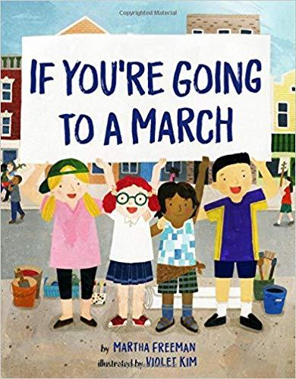
“‘If you’re going to a march, you’re going to want a sign”—and this inspiring handbook, which introduces children to the world of action and activism.
“As more and more children attend the growing number of marches across the country, this cheerful guide serves as a great reference tool and conversation starter for youthful participants. Inspired by author Martha Freeman’s own experiences, this picture book addresses many of the questions kids might have: What should I wear? How will I get there? Where will I be able to go to the bathroom? Is it okay to dance? (Yes, it is!). All the while the text stays focused on the fact that the right to assemble is a Constitutional part of our life as Americans . . . whatever our political point of view.”
Video Link: https://www.youtube.com/watch?v=XN-gZ6IJ5B4 (5:05)

3.41: We Rise, We Resist, We Raise Our Voices editors Wade Hudson and Cheryl Hudson (2018)
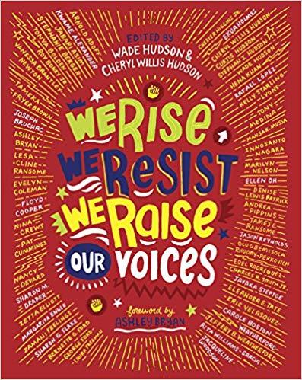
“What do we tell our children when the world seems bleak, and prejudice and racism run rampant? With 96 lavishly designed pages of original art and prose, fifty diverse creators lend voice to young activists.
Featuring poems, letters, personal essays, art, and other works from such industry leaders as Jacqueline Woodson (Brown Girl Dreaming), Jason Reynolds (All American Boys), Kwame Alexander (The Crossover), Andrea Pippins (I Love My Hair), Sharon Draper (Out of My Mind), Rita Williams-Garcia (One Crazy Summer), Ellen Oh (cofounder of We Need Diverse Books), and artists Ekua Holmes, Rafael Lopez, James Ransome, Javaka Steptoe, and more, this anthology empowers the nation’s youth to listen, learn, and build a better tomorrow.” (Recommended for ages 10+)
Video Link: https://www.youtube.com/watch?v=jTKAVzZE8r0 (6:01) (reading of two excerpts)

3.42: Around America to Win the Vote: Two Suffragists, a Kitten, and 10,000 Miles by Mara Rockliff, author and Hadley Hooper, illustrator (2016)
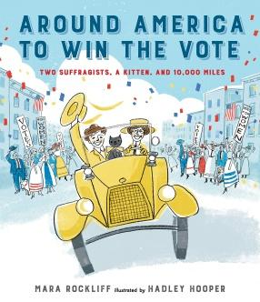
“In April 1916, Nell Richardson and Alice Burke set out from New York City in a little yellow car, embarking on a bumpy, muddy, unmapped journey ten thousand miles long. They took with them a teeny typewriter, a tiny sewing machine, a wee black kitten, and a message for Americans all across the country: Votes for Women! The women’s suffrage movement was in full swing, and Nell and Alice would not let anything keep them from spreading the word about equal voting rights for women. Braving blizzards, deserts, and naysayers—not to mention a whole lot of tires stuck in the mud—the two courageous friends made their way through the cities and towns of America to further their cause.”
Video Link: https://www.youtube.com/watch?v=9zX_-mjl2P0 (15:33)

3.43: Winston of Churchill: One Bear’s Battle Against Global Warming by Jean Davies Okimoto, author and Jeremiah Trammell, illustrator (2007)
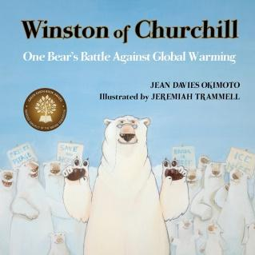
“Churchill, Manitoba is the polar bear capitol of the world. Every winter, tourists flock to the tiny town to watch the bears hunt and frolic on the frozen waters of the Hudson Bay. This year, though, the tourists are in for a big surprise...Winston! A smart, fierce, brave bear, Winston of Churchill has noticed that their icy home is slowly melting away. He explains to the other bears why the ice is melting then, using the stirring words of his famous namesake, rallies the bears to convince humans to save their Arctic home. However, on the way to the protest march, Winston learns an unexpected lesson and realizes that he, too, must change his ways. This timely, funny story draws attention to the polar bears’ plight and helps children understand that in the face of global warming, everyone must do their part, no matter how small.”
Video Link: https://www.youtube.com/watch?v=2_p7iY1cdf0 (12:16)
Teaching Resource: https://www.teachingchildrenphilosophy.org/BookModule/WinstonOfChurchill

3.44: The People’s Painter: How Ben Shahn Fought for Justice with Art by Cynthia Levinson (Author) and Evan Turk (Illustrator) (2021)
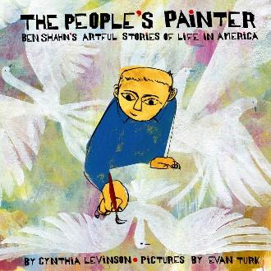
“‘The first thing I can remember,’ Ben said, ‘I drew.’”
“As an observant child growing up in Lithuania, Ben Shahn yearns to draw everything he sees—and, after seeing his father banished by the Czar for demanding workers’ rights, he develops a keen sense of justice, too.
“So. when Ben and the rest of his family make their way to America, Ben brings both his sharp artistic eye and his desire to fight for what’s right. As he grows, he speaks for justice through his art—by disarming classmates who bully him because he’s Jewish, by defying his teachers’ insistence that he paint beautiful landscapes rather than true stories, by urging the US government to pass Depression-era laws to help people find food and jobs.”
Video Link: https://www.youtube.com/watch?v=_6_9ixNWQCo (13:11)

4.0: Curriculum & Theme-Based Classroom Activities for Children

from Tapestry of Faith
4.1: Chalice Children: A Program about Our Unitarian Universalist Community for Preschoolers
4.1.1: Session 4: Making Chalices
Link: https://www.uua.org/re/tapestry/children/chalicechildren/session4
The flaming chalice was created in WW II to assist in helping refugees escape the war. It is a symbol, among other things, of activism.
“Participants will:
- Become familiar with the chalice as a symbol of our Unitarian Universalist faith. See story about the flaming chalice at https://www.uua.org/re/tapestry/children/home/session2/60017.shtml
- Begin to develop a sense of identity as a Unitarian Universalist
- Begin to understand that there are many ways to express religion.”
4.1.2: Session 6: Chalice Necklaces
Link: https://www.uua.org/re/tapestry/children/chalicechildren/session6
The flaming chalice was created in WW II to assist in helping refugees escape the war. It is a symbol, among other things, of activism.
“Participants will:
- Reinforce their understanding of the chalice as a symbol of their Unitarian Universalist faith
- Connect wonder, peace, love, and joy with the chalice
- Learn the song I’ve Got Peace Like a River.”
4.1.3: Session 8: Fruit Chalices
Link: https://www.uua.org/re/tapestry/children/chalicechildren/session8
The flaming chalice was created in WW II to assist in helping refugees escape the war. It is a symbol, among other things, of activism.
“Participants will:
- Explore the shape and parts of the chalice, using edible fruit
- Reinforce their understanding of the chalice as the symbol of Unitarian Universalism. See story about the flaming chalice at https://www.uua.org/re/tapestry/children/home/session2/60017.shtml
- Feel connected to the chalice and to their Chalice Children group.”

4.2: Creating Home: A Program on Developing a Sense of Home Grounded in Faith for Grades K-1
4.2.1: Session 2: Symbols of Faith
Link: https://www.uua.org/re/tapestry/children/home/session2
The flaming chalice was created in WW II to assist in helping refugees escape the war. It is a symbol, among other things, of activism.
“Participants will:
- Create a personal faith symbol or decorate a chalice
- Construct a chalice as a symbol of their faith home to use in their family home
- Listen and interact with the story, Flame of Learning, Chalice of Love. Explore the meaning of the components of the chalice symbol
- Learn the hymn, Spirit of Life
- Create personal symbols of faith
- Optional: Internalize the chalice story by participating in a Faith in Action project involving refugees”
4.2.2: Session 5: Home in Nature
Link: https://www.uua.org/re/tapestry/children/home/session5
This session opens up the possibility of talking about Thoreau’s view of civil disobedience/nonviolence, as well as his opposition to slavery and war.
“Participants will:
- Explore the practice of picture journaling
- Explore the connectedness of their family home, the natural world, and their faith home
- Become familiar with Henry David Thoreau’s life in nature
- Build a home in nature
- Look at nature through a window and draw their observations
- Optional: Transform a public green space through a trash clean-up project”
4.2.3: Session 10: Tango
Link: https://www.uua.org/re/tapestry/children/home/session10
The story, “A Penguin Family,” supports the right of gay couples to adopt children. The book, And Tango makes Three, has been banned by two school districts in Florida.
“Participants will:
- Play a dancing game in which they choose partners
- Honor diverse families by making badges recognizing family members and their roles
- Through a story about Tango and her family, learn about family diversity
- Identify some of the elements that bond families
- Discuss how we enter faith families
- Affirm their sense of belonging by telling stories about entering and belonging in their faith family …
- Learn that people fill more than one role in a family.”
You can also watch a video reading of the book, “And Tango makes Three” at https://www.youtube.com/watch?v=bGZHD4SKmQU (6:36). This book is also available in print and on Kindle.

4.3: Wonderful Welcome: A Program for Children Grades K-1
4.3.1: Session 2: The Gift of Covenant
Link: https://www.uua.org/re/tapestry/children/welcome/session2
While our focus on covenant has to do with it within a congregation, there is also the congregation’s implicit external covenant with the wider community, and often this means working for justice.
“Participants will:
- Learn how a covenant — agreeing on rules together and promising to follow them — supports everyone’s safety and the group’s success
- Understand a covenant as an intangible gift they can give and receive as members of a community
- Discover how their Unitarian Universalist faith is based on covenant
- Create a group covenant together
- Express covenanting through song.”
4.3.2: Session 4: The Gift of Kindness
Link: https://www.uua.org/re/tapestry/children/welcome/session4
Among other things, the Golden Rule is an invitation to activism. The story about Jesus invites a discussion about Jesus as an activist..
“Participants will:
- Explore the value of the Golden Rule
- Create a ‘Golden Ruler’ to represent being kind to others
- Learn how kindness is an important part of welcome
- Hear a story in which Jesus explains the Golden Rule.”
4.3.3: Session 10: The Gift of Protection
Link: https://www.uua.org/re/tapestry/children/welcome/session10
Caring for the earth involves often requires activism.
“Participants will:
- Learn how to take care of the Earth on a daily basis
- Spend time in mindfully in nature
- Understand ‘protection’ as an intangible gift they can give through their attitudes and actions on behalf of the Earth.”

4.4: Love Surrounds Us: A Program on the UU Principles and Beloved Community for Grades K-1 (7 sessions)
“At the core of our Unitarian Universalist community are our seven Principles. The Principles encompass all the ingredients of a good and faith-filled life based on equality, freedom, peace, acceptance, truth, care, and love. This program explores all the Principles in the context of Beloved Community.
“The program concentrates on the communities that are most recognizable to kindergartners and first graders—their Beloved Communities of family/home, school, neighborhood.”
Any of the following can be used to consider aspects of the topic of activism.
Session 10: Our Words Matter A voice and a vote / Talking Stick
Session 11: Hear Our Voices An activist named Ruby Bridges
Session 12: A Peaceful and Fair World Peace and the Beloved Community
Session 13: Peaceful Choices Dorothea Dix, free education, and reform
Session 14: Love Surrounds Us in Nature Caring for Earth
Session 15: Caring for the Earth Activist Rachel Carson
Session 16: Our UU Principles Activist Clara Barton

4.5: World of Wonder: A Program on the Seven Principles of Unitarian Universalism for Grades K-1
4.5.1: Session 3: Thanks Be for Trees!
Link: https://www.uua.org/re/tapestry/children/wonder/session3
The story of Amrita’s Tree is a compelling example of activism.
“Participants will:
- Understand the importance of each part of a tree as well as the importance of trees in our ecosystems
- Be inspired by the story of the courageous leadership of a child in saving a tree
- Experience a spiritual connection with and understanding of the life cycle of a tree.”
4.5.2: Session 13: Green Energy
Link: https://www.uua.org/re/tapestry/children/wonder/session13
The switch to green energy has been driven by activism.
“Participants will:
- Learn definitions of energy and “green” energy
- Consider a “real-life” story about green energy and community problem solving
- Understand ways to conserve energy and demonstrate leadership by encouraging others to conserve as well
- Make pinwheels or bookmarks, as a reminder of wind power”
4.5.3: Session 14: Enough Stuff
Link: https://www.uua.org/re/tapestry/children/wonder/session14
Recycling has been spurred by activists, especially over the concern of the threat that plastics present in our oceans and elsewhere.
“This session will:
- Foster an environmentalist ethic for refusing, in addition to reducing, reusing, and recycling by understanding the 5 Rs: refuse, reduce, re-use, recycle, and rot
- Explore the difference between needs and wants
- Consider a ‘no presents’ birthday party, by responding to a real-life story
- Make use of recycled materials in a creative project
- Reinforce the seventh Unitarian Universalist Principle, ‘respect for the interdependent web of all existence of which we are a part.’”
4.5.4: Session 15: Working Together to Make a Difference
Link: https://www.uua.org/re/tapestry/children/wonder/session15
The UUA’s Green Sanctuary program is an example of environmental activism.
“This session will:
- Foster an ethic of responsibility to take action to nurture and protect the web of life
- Engage participants in cooperative activities and demonstrate the power of working cooperatively with others
- Introduce the UUA’s Green Sanctuary program
- Empower participants as leaders in the group
- Reinforce the seventh Unitarian Universalist Principle, ‘respect for the interdependent web of all existence of which we are a part.’”

4.6: Moral Tales: A Program on Making Choices for Grades 2-3 (8 sessions)
“Every day our children go forth into a complex world where they are often faced with difficult decisions and situations. Moral Tales attempts to provide children with the spiritual and ethical tools they will need to make choices and take actions reflective of their Unitarian Universalist beliefs and values.”
The following sessions connect to the theme of activism.
Session 2: Conscience: Hearing The Inner Voice right of conscience
Session 4: In Another’s Shoes cultivating perspective and empathy
Session 8: Do unto Others Golden Rule and Good Samaritan
Session 10: Footprints: Treading Softly on Earth 7th Principle & Earth Justice
Session 12: Making a Difference Risk taking in the face of injustice
Session 13: Justice for All Acting against injustice and lack of equity
Session 14: Courage Acting with courage due to conscience and compassion
Session 15: Courage and Perseverance Importance of perseverance in face of
injustice

4.7: Faithful Journeys: A Program about Pilgrimages of Faith in Action for Grades 2-3 (11 sessions)
“Participants embark on a pilgrimage of faith, exploring how Unitarian Universalism translates into life choices and everyday actions. In each session, they hear historic or contemporary examples of Unitarian Universalist faith in action. Stories about real people model how participants can activate their own personal agency – their capacity to act faithfully as Unitarian Universalists – in their own lives, and children have regular opportunities to share and affirm their own stories of faithful action. Through sessions structured around the Unitarian Universalist Principles, Faithful Journeys demonstrates that our Principles are not a dogma, but a credo that individuals can affirm with many kinds of action. Over the course of the program, children discover a unity of faith in the many different ways Unitarian Universalists, including themselves, can act on our beliefs.”
Most of the sessions in Faithful Journeys connect to activism.
Session 3: Welcoming Superman Disability Justice
Session 4: Be Fair Focus on justice, equity, and compassion
Session 7: Create Magic, Change the World faithful intention and focusing energy are the magic to combat injustice
Session 8: Seek Truth Afro-Caribbean Unitarian minister Egbert Ethelred Brown’s journey of seeking truth
Session 9: Ask Questions importance of questioning to a free and responsible search for truth and meaning
Session 10: Speak Out Demonstrate how standing up to others, including those in power, in order to follow one’s conscience can be an act of faith
Session 11: Get Involved Focus on marriage equality
Session 12: Make Peace Adin Ballou and the goal of world community with peace, liberty, and justice for all
Session 13: Build World Community Partner Church Program & 6th principle
Session 14: Honor Life Beatrix Potter, 7th principle & earth justice
Session 15: Protect the Earth Change the World Kids & 7th principle

4.8: Love Will Guide Us: A Program for Grades 2-3 that Applies the Wisdom of the Six Sources to the Big Questions
4.8.1: Session 15: Love in Action
Link: https://www.uua.org/re/tapestry/children/loveguide/session15
Our second source reminds us of prophetic women and men and the ways in which their activism made a difference. Former slave Harriet Tubman was an activist who risked her life again and again on the Underground Railroad, but she did much more. See https://www.battlefields.org/learn/biographies/harriet-tubman.
“Participants will:
- Explore the second Unitarian Universalist source, in child-friendly language “The people of long ago and today whose lives remind us to be kind and fair,” through a story about Harriet Tubman and the Underground Railroad
- Discuss the “bystander” role and experience, in role play, ways a bystander can choose to get involved when something is wrong
- Explore what makes a good leader and practice ways to respond to injustice, unkindness, or when a leader promotes a poor choice
- Develop empathy through identifying with enslaved people seeking freedom.”
4.8.2: Session 16: Love Is the Golden Rule
Link: https://www.uua.org/re/tapestry/children/loveguide/session16
The term, “Golden Rule activist,” understands the Golden Rule as a motivation for activism. See https://interfaithmovement.com/news/how-to-live-authentically-as-a-golden-rule-activist-published-livegolden-article/. The Golden Rule is also the name of a sailboat used to protest nuclear weapons. See https://www.friendsjournal.org/historic-peace-activism-sailboat-golden-rule-to-make-another-voyage/ and https://www.gzcenter.org/following-the-golden-rule/.
“Participants will:
- Demonstrate and strengthen knowledge of the seven Unitarian Universalist Sources, as expressed in child-friendly language
- Explore in both religious and concrete terms what it means to be guided by love as the Golden Rule
- Express understanding of the connections among our faith, our Sources, and love, by creating Love Will Guide Us night sky displays.”

4.9: Signs of Our Faith: A Program about Being UU Every Day for Grades 2-3
4.9.1: Session 15: Witness for Justice: Public Signs of Our UU Values
Link: https://www.uua.org/re/tapestry/children/signs/session15
Public witness is an important element of activism.
“This session will:
- Show that public witness for justice is a sign of our faith
- Introduce John L. Cashin, a UU ancestor who showed his faith through public witness
- Demonstrate multiple ways to make public witness
- Explore the congregation’s public witness ministry.”

4.10: Toolbox of Faith: A Program That Helps Children Discover the Uses of Faith, Grades 4-5 (4 sessions)
“Toolbox of Faith invites fourth- and fifth- grade participants to reflect on the qualities of our Unitarian Universalist faith, such as integrity, courage, and love, as tools they can use in living their lives and building their own faith. Each of the 16 sessions uses a tool as a metaphor for an important quality of our faith such as reflection (symbolized by a mirror), flexibility (duct tape), and justice (a flashlight).”
The following sessions connect to the theme of activism.
Session 5: Reflection (Mirror) The “still, small voice,” ethical discernment & 4th principle
Session 7: Democratic Process (Chalk) Focus on the right to vote for women
Session 8: Power (Hammer) Abolitionists exercise power by defying The Fugitive Slave Law
Session 10: Courage And Conviction (Saddlebags) 19th century Universalist circuit-riding preachers and how they acted on the courage of their convictions

4.11: Windows and Mirrors: A Program about Diversity for Grades 4-5 (6 sessions)
“Windows and Mirrors nurtures children’s ability to identify their own experiences and perspectives and to seek out, care about, and respect those of others. The sessions unpack topics that lend themselves to diverse experiences and perspectives—for example, faith heritage, public service, anti-racism and prayer.”
The following sessions connect to the theme of activism.
Session 8: Eyes On The Prize Learning to be a social justice ally
Session 10: Service Is The Rent We Pay For Living Exploring the challenge of public service work and its value
Session 11: Privilege Is A Blessing We Give Away To Be In Community The use of her white privilege by Juliette Hampton Morgan to fight racial injustice
Session 12: Making Visible The Invisible Exploring the problems created by social class that should not exist
Session 13: Images Of Injustice Explore the differences between “haves” and “have-nots” through a story about Charles Dickens
Session 14: All Work Has Honor Explore the “dignity of work,” our 1st principle, and child labor

4.12: Love Connects Us: A Program on Living in Unitarian Universalist Covenant for Grades 4-5 (5 sessions)
“Love Connects Us celebrates important ways Unitarian Universalists live our faith in covenanted community. Moved by love and gathered in spirit, we embrace our responsibility toward one another and the world at large. We encourage one another’s search for truth and meaning. We strive to be active in peace-making and other efforts to improve our world.”
The following sessions connect to the theme of activism.
Session 7: One Person Makes a Difference Explore the story of Craig Keilburger who helped found Free the Children as a teenager and the work the organization has down.
Session 8: The Power of Peace Explore how nonviolence and civil disobedience by Thoreau, Gandhi & King exemplify Unitarian Universalist values.
Session 9: Kindness is the Key Explore the power of individuals to create peace
Session 10: Peace Inside Seeking peace within as a means of bringing peace to one’s relationships, communities, and the wider world
Session 15: All Work Together Focus on homelessness and helping homeless people

4.13: Sing to the Power: A Social Justice Program for Children Grades 4-5 (5 sessions)
“Sing to the Power affirms our Unitarian Universalist heritage of confronting “powers and structures of evil with justice, compassion, and the transforming power of love.” Participants experience their own power, and understand how it can help them to be leaders.”
The following sessions connect to the theme of activism.
Session 10: The Power of Passion Explore the power of change by discussing the story of Hannah Salwen and her family’s journey to create change
Session 11: The Power of Action Learn how Bill McKibben founded 350.org to combat climate change
Session 12: The Power of Reaching Out Explore the story of how one UU congregation connected with thousands of people in attempting to prevent the deportation of Raύl Cardenas, the husband of their member, Judy Cardenas
Session 14: The Power of Persistence Explore the persistence of Phebe Hanford, a Universalist minister, who worked for women’s suffrage for some 60 years and finally lived to see women get the right to vote
Session 15: The Power of Gathering Explore how the California UU Legislative Ministry’s Water Justice Tours which engage young people in protecting clean water

4.14: Riddle and Mystery: A Program on the Big Questions for Grade 6
4.14.1: Session 3: Looking Toward Tomorrow
Link: https://www.uua.org/re/tapestry/children/riddle/session3
Rachel Carson was an inspiring environmental activist.
“Participants will:
- Consider who and what controls the future
- Discern their own ability to shape their lives and human history
- Understand how quotidian events can affect cosmic outcomes
- Appreciate how Rachel Carson affected our shared future
- Recognize Unitarian Universalism as a humanistic religion
- Explore a Unitarian Universalist perspective about where humanity should be going and our role in moving ourselves forward into our future.”
4.14.2: Session 8: Speaking of Fair
Link: https://www.uua.org/re/tapestry/children/riddle/session8
Fairness is a fundamental motivation for actvism.
“Participants will:
- Evaluate whether particular scenarios and life, in general, are fair
- Learn about Unitarian Universalist youth and adult efforts to correct injustice
- Apply Unitarian Universalist Principles and values to address hypothetical, typical sixth-grade fairness situations
- Optional: Create video news reports about Unitarian Universalist youth social justice efforts.”
4.14.3: Session 11: Touching All
Link: https://www.uua.org/re/tapestry/children/riddle/session11
Unitarian Henry Bergh, Unitarian founder of the American Society for the Prevention of Cruelty to Animals, was an animal rights activist.
“Participants will:
- Pose the Big Question ‘How am I connected with everything else?’ and explore Unitarian Universalist responses
- Help youth discover to what they are connected
- Explore the Unitarian Universalist image of the web of all existence and engage youth to reflect on their own place within the web.
- Understand how a sense of belonging is linked to a sense of responsibility
- Reflect on human connection to one another and to all life
- Learn about Henry Bergh, Unitarian founder of the American Society for the Prevention of Cruelty to Animals
- Explore Unitarian Universalist statements about connection.”

4.15: Amazing Grace, 6th Grade: Exploring Right and Wrong
4.15.1: Session 6: The First U
Link: https://www.uua.org/re/tapestry/children/grace/session6
James Luther Adams and James Reeb were inspiring UU activists.
“Participants will:
- Understand a core idea of early Unitarianism
- Hear of two outstanding Unitarians and the consequences of their actions
- Discuss the consequences of human actions, especially wrong acts
- Consider appropriate punishments for doing wrong
- Optional: Learn of their congregation’s efforts to right wrongs
- Optional: Examine opposing views of a controversial ethical issue.”
4.15.2: Session 8: UUs In Action

Link: https://www.uua.org/re/tapestry/children/grace/session8
Activity 2: Conundrum Corner - Speaking of UUs and Social Justice illustrates how activism works to balance the scales of justice.
“Participants will:
- Explore Christian scriptural attitudes toward social justice through the stories of the good shepherd and the lost sheep
- Play roles in a hypothetical scenario where ethical decisions are demanded
- Question the role faith plays in their decision-making process
- Hear how one UU incorporates social justice themes in his music
- Optional: Find magazine accounts of UU social justice projects”
4.15.3: Session 15: Saving the World
Link: https://www.uua.org/re/tapestry/children/grace/session15
This session encourages participants to consider how small actions can lead to significant results. By its nature, activism is the accumulation of small actions to effect significant change.
“Participants will:
- Consider the wide impact of their own ethical decisions
- Understand the power of accumulative action
- Express and encourage universal love
- Explore the butterfly effect.”

4.16: Gather the Spirit: A Multigenerational Program about Stewardship
4.16.1: Workshop 8: Gather to Celebrate
Link: https://www.uua.org/re/tapestry/multigenerational/gather/workshop8
Water stewardship, especially in the context of global warming, is an important aspect of environmental activism.
“Participants will:
- Experience how working together advances a shared goal
- Hear a contemporary story of social action and water stewardship;
- Learn about activist, musician and Unitarian Universalist Pete Seeger
- Consider how boating affects water resources
- Commit to specific actions to conserve water, protect water resources and/or promote equitable sharing of Earth’s water”

4.17: Circle of Trees: A Multigenerational Program about Nourishing Deep Connections with Nature
4.17.1: Workshop 8: Come Be With Trees
Link: https://www.uua.org/re/tapestry/multigenerational/trees/workshop8
Wangari Maathai (1940-2011) founded the Green Belt Movement, an activist project to rebalance environmental degradation, deforestation, and food insecurity, which has resulted in the planting of over 51 million trees.
“Participants will:
- Directly engage with trees and nature in a variety of ways
- Gain inspiration and a sense of empowerment from the story of Wangari Maathai
- Build on their understanding of and respect for trees through multiple modes of learning, including movement, meditation, and song
- Experience multigenerational learning.”

4.18: Miracles: A Multigenerational Program on Living in Awe and Wonder
4.18.1: Session 6: The Miracle of Social Change
Link: https://www.uua.org/re/tapestry/multigenerational/miracles/session-6
The miracle of social change is the result of activism.
“Participants will:
- Explore what they believe constitutes a ‘miracle’ as they share experiences of ‘miracle moments’
- Feel empowered as agents for change through the metaphor of the ripple effect in water
- Identify community and global situations that ‘need a miracle’ and explore how individual action, grounded in love, could create the needed transformation.”

4.19: Heeding the Call: A Program on Justice-making for Junior High School Youth (10 sessions)
“Heeding the Call is a social justice curriculum that not only explores linked oppressions in our society, but also encourages participants towards personal growth in values that counteract the marginalization of others. Workshops on empathy, courage, abundance, joy, and other qualities ask participants to recognize how these standards can be tools for justice. Additionally, the program includes more concrete tools, such as suggestions on how to be a good ally and tips on the language of conflict resolution.”
The following sessions connect to the theme of activism.
Workshop 1: The Call for Awareness Explore the difference between “band-aid” approaches to systemic action that looks at the root causes of injustice
Workshop 2: The Call of Our Unitarian Universalist Heritage Activist Frances Harper (1825-1911) focused on the rights of black women and the right of all women to vote
Workshop 3: The Call for Understanding Activist Raziq Brown
In Peace Begins With Me, Raziq Brown shares his reflections on a visit to Sierra Leone and the terrible plight of children there. See his two photo albums at https://www.flickr.com/photos/raziqbrown/albums
See Nights Can Be Tough by Kenny Wiley about police harassment & arrest of Raziq Brown
https://www.uuworld.org/articles/nights-can-be-tough Also see a reflection, A Failure by Raziq Brown at https://www.uua.org/worship/words/reflection/failure
Workshop 4: The Call for Empathy Explore empathy as an important quality in justice making. Consider story of leaving water in the Arizona desert for immigrants.
Workshop 5: The Call for Courage Explore courage as an important quality in justice making. The story is about Juliette Hampton Morgan (1914-1957) who used her white privilege to protest the treatment of Blacks by the bus drivers in Montgomery, Alabama.
Workshop 6: The Call for Cooperation Explore how one village is cooperating to try to build peace in the Middle East and understand the role of cooperation in activism.
Workshop 8: The Call for Peace Learn about the Children’s Movement for Peace in Colombia and how children made a difference through their quest for peace.
Workshop 10: The Call for Joy Explore the importance of joy in activism and through the story Clowning for Joy in Haiti
Workshop 11: The Call for Forgiveness Forgiveness is important in Restorative Justice, a unique method of activism
Workshop 12: The Call for Responsible Leadership The story about the aftermath of Hurricane Katrina illustrates do-it-yourself activism and leadership.

4.20: Building Bridges: A World Religions Program for 8th-9th Grades
4.20.1: Workshop 2: Unitarian Universalism: The Journey Starts at Home
Link: https://www.uua.org/re/tapestry/youth/bridges/workshop2/186368.shtml
The story, Lydia Maria Child: Voice for the Oppressed, is about an amazing 19th century activist who worked on behalf of Native Americans and Blacks.
“Participants will:
- Become familiar with and able to discuss aspects of Unitarian Universalist history
- Explore several aspects of Unitarian Universalism, including our Principles, our Sources, and our commitment to social justice
- Reflect how their faith influences their daily lives
- Articulate some differences between historical Unitarianism and historical Universalism.”
4.20.2: Workshop 17: The Quakers: Lamb and Lion
Link: https://www.uua.org/re/tapestry/youth/bridges/workshop17
Lucretia Mott became a minister. As an activist she focused on the evils of slavey and the subjugation of women.
“Participants will:
- Discuss important concepts of Quakerism
- Discuss the story of Lucretia Mott and the current state of women’s rights
- Explore what it means to commit to living for peace
- Explore the value of simplicity or plainness, as espoused by the Friends (Alternate Activity 2)
- Appreciate the impact a small, courageous group of people can have on the world.”
4.20.3: Workshop 18: Humanism: Just Us... And Everything Else
Link: https://www.uua.org/re/tapestry/youth/bridges/workshop18
The story for this session is about a congregation that issues Passports to Justice to encourage members to be activists working for justice.
“Participants will:
- Learn the history and tenets of Humanism
- Identify Humanistic tendencies in their own beliefs and values
- Understand Humanism’s influence in Unitarian Universalism and in other institutions of our society
- Consider ways Humanism can function as a religion, and explore the compatibility of Humanism and spirituality for themselves.”

4.21: Other Resources
4.21.1: Civil Rights Activity Book
This 28-page pdf booklet provides a lot of information about the Civil Rights movement. It includes a page about Viola Liuzzo.
Link: https://www.splcenter.org/sites/default/files/splc_civil_rights_activity_book_online.pdf

Resources for Youth
5.0: Curriculum & Theme-Based Classroom Activities for Youth
Tapestry of Faith
Youth
5.1: A Chorus of Faiths: A Program That Builds Interfaith Youth Leaders
5.1.1: Workshop 2: We Need Not Think Alike to Love Alike
Link: https://www.uua.org/re/tapestry/youth/chorus/workshop2/173577.shtml
The story of Martha and Waitstill Sharp illustrates activism in actions and establishes the flaming chalice as a symbol of activism..
“Participants will:
- Understand the Golden Rule as an example of a Unitarian Universalist value inherited from our Judeo-Christian tradition
- Learn the story of the Unitarian Universalist flaming chalice symbol and hear about the interfaith service work of Unitarians Martha and Waitstill Sharp during World War II
- Map their community’s assets for diverse, interfaith cooperation in service work
- Move the group’s interfaith service project forward by identifying potential partners and projects in their community
- Recognize and reflect on the importance of human similarities and differences.”
5.1.2: Workshop 3: The Beloved Community
Link: https://www.uua.org/re/tapestry/youth/chorus/workshop3
The march at Selma was a turning point in the Civil Rights movement. It illustrates the power of protest in the work of activism.
“Participants will:
- Learn about the Unitarian Universalist participation in the march at Selma
- Understand the history of interfaith cooperation in the world and come up with ideas for emulating it
- Learn about interfaith work Unitarian Universalists do in their local community
- Discover how interfaith work can deepen faith identity
- Move the group’s interfaith service project forward by planning the next action steps.”
5.1.3: Workshop 7: Service is Our Prayer
Link: https://www.uua.org/re/tapestry/youth/chorus/workshop7
The story of the Faithful Fools is a story about activists in the Tenderloin District of San Francisco.
“Participants will:
- Incorporate communal narratives and “big stories” into their personal stories of interfaith cooperation
- Practice changing the conversation when faced with religious conflict, bigotry, or stereotypes
- Revisit interfaith stories explored earlier in this program.”

5.2: Exploring Our Values Through Poetry: A Program for High School Youth
5.2.1: Workshop 7: Difficult Times
Link: https://www.uua.org/re/tapestry/youth/poetry/workshop7
Difficult times come to almost everyone, and they can cause harm in relationship, which can be addressed through reconciliation. Racism is in a different category because it is rooted in over 400 years of oppression. While collective truth and reconciliation is needed, how might individual reconciliation be pursued? What harm can it ease? What hope can it offer? How can activism lead to reconciliation?
“Participants will:
- Recognize some of the common dilemmas of our human existence
- Reflect upon the way several poets and songwriters have explored these dilemmas
- Acknowledge hope as an important tool in our work to right society’s wrongs
- Express shared truths about the human condition in writing
See poem for Activity 3: Racism and the poem, Poem for the Young White Man Who Asked Me How I, an Intelligent, Well-Read Person, Could Believe in the War between the Races by Lorna Dee Cervantes

5.3: A Place of Wholeness: A Program for Youth Exploring Their Own Unitarian Universalist Faith Journeys
5.3.1: Workshop 1: Beginning Together
Link: https://www.uua.org/re/tapestry/youth/wholeness/workshop1
The story of David and Goliath informed James Luther Adams’ consideration of the five smooth stones, which informs activism within Unitarian Universalism.
“Participants will:
- Worship together
- Encounter James Luther Adams’ concept of the Five Smooth Stones of Religious Liberalism
- Learn about the program’s key themes and activities
- Make connections between migrations and spiritual journeys
- Learn about each other and each person’s Unitarian Universalist or religious ‘biography’
- Create a journal to use throughout the program.”
5.3.2: Workshop 4: A Theology of Love
Link: https://www.uua.org/re/tapestry/youth/wholeness/workshop4
The story, The Pride Rainbow Project, is an example of using art in the service of activism.
“Participants will:
- Understand the historical roots of the Universalist theology of love as it relates to salvation and God
- Reflect on what the Universalist theology of love means for them and for Unitarian Universalists today, including how they live it out; what its limits are, and what it says about evil
- Identify where a theology of love shows up in the Unitarian Universalist Principles and the actions of Unitarian Universalist congregations today.”
5.3.3: Workshop 8: Freedom
Link: https://www.uua.org/re/tapestry/youth/wholeness/workshop8
The story, Viola Liuzzo, To Freedom Land, lifts up her passion, courage, and sacrifice. Her activism in Selma continues to inspire.
“Participants will:
- Learn about the historical and theological importance of freedom in Unitarian Universalism
- Understand that freedom has different meanings for different people and communities
- Reflect on the role of freedom in their life and faith, and the connection between freedom and responsibility
- Optional: Explore the difference between liberalism and liberation theology.”
5.3.4.: Workshop 9: Tolerance
Link: https://www.uua.org/re/tapestry/youth/wholeness/workshop9
The story of the “Unitarian Universalist Racial Justice Timeline” illustrates our activism against racism, including serious errors that are not always lifted up.
“Participants will:
- Understand the historical roots of the theology of tolerance and how that term was radical for its time
- Learn that Unitarian Universalists have had both successes and failures living up to their ideals of justice
- Identify how tolerance is expressed in their own lives and their religious communities
- Develop tools for interacting with others with diverse identities and learn strategies for being themselves in intolerant environments.”
5.4: Virtue Ethics: An Ethical Development Program for High School Youth
5.4.1: Workshop 5: Fairness
Link: https://www.uua.org/re/tapestry/youth/virtueethics/workshop5
The life of activist Lotta Hitschmanova continues to be awe-inspiring. She helped create the Unitarian Service Committee of Canada and foster its work.
“Participants will:
- Explore the meaning of fairness
- Learn about Lotta Hitschmanova, Czech- and Jewish-born refugee who escaped Nazism, immigrated to Canada, and directed the Unitarian Service Committee of Canada’s work in international aid
- Discuss dilemmas where fairness is tested
- Identify ways they do or could practice fairness, and commit to the future practice of fairness in their lives.”

6.0: Readings
6.1: Hope in the Dark (287 words)
Rebecca Solnit, a renowned writer, historian, and activist, has made significant contributions to the field of activism through her insightful and thought-provoking works. Solnit’s writings often explore themes of power, social change, and the role of activism in shaping the world.
One of Solnit’s notable books is Hope in the Dark: Untold Histories, Wild Possibilities, which examines the importance of hope and perseverance in activism. In this book, Solnit argues that even in times of darkness and despair, activists must continue their work because change is often unpredictable and arises from unexpected places. She emphasizes the need for sustained, collective action and highlights the impact that seemingly small victories can have in bringing about larger social transformations.
Solnit also explores the concept of “prefigurative politics,” which suggests that activists should strive to embody the values and principles they are fighting for in their own organizing and community-building efforts. She believes that activism should not solely focus on achieving specific goals but should also be a process of creating alternative systems and ways of being that challenge the dominant paradigm.
Solnit also frequently addresses the intersection of activism and gender. In her essay collection Men Explain Things to Me, she coined the term “mansplaining” to describe the phenomenon of men condescendingly explaining things to women, often disregarding their expertise and knowledge. Solnit’s work highlights the importance of addressing gender dynamics within activism and the broader social context.
Throughout her writings, Solnit encourages activists to embrace uncertainty, maintain hope, and recognize the collective power of ordinary people to effect meaningful change. Her work has inspired many individuals to engage in activism and has provided valuable insights into the challenges and possibilities of creating a more just and equitable world.
Source: Touchstones

6.2: Turning the Ship of Justice by Jack Kornfield (273 words)
Whether we stand up politically or work in our schools, …we need to offer our voice, our way. It may be that our particular gifts manifest as caring for children, or in law, commerce, or music, in computer networking, or gardening. It is …allowing our unique and singular voice to move in harmony with a living purpose.
For if we are not able to remember our part in the cathedral, to offer our particular gifts, contribute our particular voice, our life becomes a great sorrow. Losing that vision, our spirits shrink and deaden. Even in the simplest tasks, we have this choice. …The expression of our gift need not be grand. Everyone who writes poetry does not need to publish ten volumes and win the National Book Award. The farmer in rural Asia who works his family’s meager land for survival can plow with a song on his lips, can bring his inspired prayers to the mosque, can add his poetic voice to the village. He too is transforming the world.
One meditation teacher describes the impact of each small contribution as a ‘trim-tab effect.’ When an ocean liner is under way …it cannot be steered by moving its rudder. Instead, a series of adjustments is made in the flaps at the edge of the rudder — the trim tabs. These small changes begin to shift the direction of the ship until the rudder itself can be turned…. Like trim tabs, our deliberate actions, however small, can change the course of life around us. To use our life to move the world toward compassion and away from suffering is the only thing that matters.
Source: https://www.spiritualityandpractice.com/book-reviews/excerpts/view/13527

6.3: A Mysticism of Action by Pierre Teilhard de Chardin & Ursula King (277 words)
Besides the current western interest in the mystical heritage of the world’s religions, there exists another, quite different area of dynamic growth where religious insights are applied to the transformation of the social order. The message of spiritual freedom is related to the liberation of human beings from external structures of oppression, whether expressed in the liberation theology of South America or in socialist reinterpretations of Buddhism in South Asia. In a way, the greatest religious problem today is how to be both a mystic and a militant, as Adam Curle has said. In other words, how to combine the search for an expansion of inner awareness with effective social action, and how to find one’s true identity in the synthesis of both.
The necessary return to the center must not only be a journey inward, but it must help to weave new connections to the outer world. Interfaith dialogue that remains a monologue …is …not enough. The need for a new spirituality, a new mysticism of action, is …greater and universal. …The new religious vision for today cannot be found in an eclectic spiritual syncretism or in a return to simpler states of inwardness and withdrawal based …on …meditation. Teilhard saw this clearly and, like Jung, he warned westerners not to seek in the East what they cannot find there: an integral spirituality for the modern world. Spirituality is not meant to be an alternative lifestyle, a road of retreat and escape; it needs to be an active leaven of life, feeding the zest and healing the wounds of life. Seen from an evolutionary perspective, spirituality can help us to grow and make the world advance.
Source: https://www.spiritualityandpractice.com/book-reviews/excerpts/view/22034

6.4: Dismiss Whatever Insults Your Soul by Walt Whitman
“This is what you shall do; Love the earth and sun and the animals, despise riches, give alms to every one that asks, stand up for the stupid and crazy, devote your income and labor to others, hate tyrants, argue not concerning God, have patience and indulgence toward the people, take off your hat to nothing known or unknown or to any man or number of men, go freely with powerful uneducated persons and with the young and with the mothers of families, read these leaves in the open air every season of every year of your life, re-examine all you have been told at school or church or in any book, dismiss whatever insults your own soul, and your very flesh shall be a great poem and have the richest fluency not only in its words but in the silent lines of its lips and face and between the lashes of your eyes and in every motion and joint of your body.”
Source: Leaves of Grass, preface by Walt Whitman

6.5: From Activism to Cynicism by Jim Wallis (267 words)
Prophetic faith does not see the primary battle as the struggle between belief and secularism. It understands that the real battle, the big struggle of our times, is the fundamental choice between cynicism and hope. The prophets always begin in judgment, in a social critique of the status quo, but they end in hope — that these realities can and will be changed. The choice between cynicism and hope is ultimately a spiritual choice, one that has enormous political consequences.
First, let’s be fair to the cynics. Cynicism is the place of retreat for the smart, critical, dissenting, and formerly idealistic people who are now trying to protect themselves. They are not naive. They tend to see things as they are, they know what is wrong, and they are generally opposed to what they see. These are not people who view the world through rose-colored glasses, the ones who tend to trust authority or who decide to live in denial. They know what is going on, and at one point, they might even have tried for a time to change it. But they didn’t succeed; things got worse, and they got weary. Their activism, and the commitments and hopes that implied, made them feel vulnerable. So they retreated to cynicism as the refuge from commitment.
Cynicism does protect you in many ways. It protects you from seeming foolish to believe that things could and will change. It protects you from disappointment. It protects you from insecurity because now you are free to pursue your own security instead of sacrificing it for a social engagement that won’t work anyway.
Source: God’s Politics by Jim Wallis

6.6: Courageous Compassion by Thupten Jinpa (277 words)
When we make a habit of compassion in our everyday lives through regular practice and action, we live with more courage, less stress, and greater freedom. In time, we will automatically see ourselves and the world in terms of the interconnectedness of ourselves and others. Our default position toward other people will be as fellow humans rather than sources of antagonism and threat. Our new, other-oriented habits will free us from the old habits of self-judgment, self-protection, and worrying about ourselves that they replace. …We will come to embody compassion, not just admire it as an ideal. We will learn to live it through our thoughts, feelings, and behavior. In short, making a habit of compassion will transform our lives.
Being compassionate does not make us timid or tolerant of injustice. On a societal level, in fact, a truly compassionate response to injustice stems from a sense of strong moral outrage—a form of anger, but a constructive one. It was moral outrage that spurred Mahatma Gandhi to lead the Indian people to freedom from British Colonial rule, drove Abraham Lincoln to his campaign against slavery, Rosa Parks to courageously defy bus segregation one cold December morning in Montgomery, Alabama, and Nelson Mandela to lead a lifelong campaign against the apartheid system. Thanks to their strong sense of moral outrage and courage, today our world is a better place. What sustains the amazing courage of the young Pakistani activist Yousufzai Malala is her moral outrage at the injustice of the Taliban’s ban on education of girls. At the root of their moral outrage: a deep concern for the welfare of others, especially the weak and the downtrodden.
Source: https://www.spiritualityandpractice.com/book-reviews/excerpts/view/28043

6.7: Carson’s Courage by Terry Tempest Williams (257 words)
…Rachel Carson’s spirit is among us. Like her, we can be both fierce and compassionate at once. …We can carry a healthy sense of indignation within us that will shatter the complacency that has seeped into our society in the name of all we have lost, knowing there is still so much to be saved.
Call it sacred rage, rage grounded in the understanding that all life is intertwined. And we can come to know and continue to learn from the grace of wild things as they hold an organic wisdom that sustains peace
…Do we have the moral courage to step forward and openly question every law, person, and practice that denies justice toward nature?
…And do we have the imagination to rediscover an authentic patriotism that inspires empathy and reflection over pride and nationalism?
Rachel Carson’s name is synonymous with courage. She dared to expose the underbelly of the chemical industry and show how it was disrupting the balance of nature. In Silent Spring we see her signature strengths on the page, and witness how a confluence of poetry and politics with sound science can create an ethical stance toward life. But perhaps Rachel Carson’s true courage lies in her willingness to align science with the sacred, to admit that her bond toward nature is a spiritual one.
... I walked outside and sat on our back porch. The blinking bodies of fireflies were rising and falling above the grasses. They appeared as a company of code talkers flashing S.O.S. on a very dark night.
Source: https://www.spiritualityandpractice.com/book-reviews/view/28781/patriotism-and-the-american-land

6.8: Spiritual Activism by Michael Singer (248 words)
I’m an environmentalist and I’m very much into cars that get high mileage and don’t pollute, and I see that somebody’s driving a Hummer. It’s a classic example, somebody’s driving a Hummer, and I’m radicalized and I blow it up. Well, you have just caused more damage to the environment blowing up that Hummer than any pollution it will ever cause by its burning gas. Do you understand that? What you did is you reacted to your own anger, your own inability to handle a situation.
What do you mean? …What came up was anger, what came up was fear, what came up was hatred, right? What came up inside of you is hate and you expressed it, right?
That is not proper activism. Proper activism altogether, which is spiritual activism, is you first let go of your own reaction; you let go of the personal part of your being that is reacting because of the personal part of another person’s being, because all that creates is war. So you let it go. Now, you are faced with clarity that I care about—…caring about the environment.
So, you start letting go of this part of you, the same part we’ve talked about in the entire conversation. You let it go. Don’t justify this righteous anger. There’s no such thing. You let it go. Now you’re clear. The one who’s clear will see solutions. They may be small steps, but at least they’re steps in the right direction.
Source: https://www.awakin.org/v2/read/view.php?tid=2280

6.9: 12 Rules for Activists by Saul Alinsky (320 words)
- “Power is not only what you have, but what the enemy thinks you have.” Power is derived from two main sources – money and people. …
- “Never go outside the expertise of your people.” It results in confusion, fear, and retreat. Feeling secure adds to the backbone of anyone. …
- “Whenever possible, go outside the expertise of the enemy.” Look for ways to increase insecurity, anxiety, and uncertainty. …
- “Make the enemy live up to its own book of rules.” If the rule is that every letter gets a reply, send 30,000 letters. …No one can possibly obey all of their own rules. …
- “Ridicule is man’s most potent weapon.” There is no defense. It’s irrational. It’s infuriating. It also works as a key pressure point to force the enemy into concessions. …
- “A good tactic is one your people enjoy.” They’ll keep doing it without urging and come back to do more. They’re doing their thing, and will even suggest better ones. …
- “A tactic that drags on too long becomes a drag.” Don’t become old news. …
- “Keep the pressure on. Never let up.” Keep trying new things to keep the opposition off balance. As the opposition masters one approach, hit them from the flank with something new. …
- “The threat is usually more terrifying than the thing itself.” Imagination and ego can dream up many more consequences than any activist. …
- “If you push a negative hard enough, it will push through and become a positive.” Violence from the other side can win the public to your side…. …
- “The price of a successful attack is a constructive alternative.” Never let the enemy score points because you’re caught without a solution to the problem.
- “…Pick the target, freeze it, personalize it, and polarize it.” Cut off the support network and isolate the target from sympathy. Go after people and not institutions; people hurt faster than institutions. …
Source: https://sliwainsights.com/saul-alinskys-12-rules-for-radicals/

6.10: 7 ways to support the young activists by Dr. Jessica K. Taft (239 words)
Many children and youth see injustices in the world around them and want to address those injustices to create a better world. …We can help or hinder their efforts. Here are some tips about how to support their leadership and work.
1. Question your own assumptions: …As adults, we need to unlearn …misconceptions and question our tendencies to see ourselves as the experts and youth as just students or “future leaders.”
2. Be ready to learn: Adults need to really hear what young people are saying and …learn from what they are doing. …
3. Offer resources: …We can provide financial support, introduce youth to key decision-makers or influential members of our communities, give them rides, cook meals, and offer our …living rooms, or classrooms for their meetings.
4. Provide institutional memory and continuity: …Adults can provide important information about …how institutions have responded in the past. This can be especially important when institutions have made commitments that are not being fulfilled.
5. Offer supportive labor: …Adults can provide encouragement and care…. We can also offer material labor….
6. Don’t talk too much or take the lead: …We need to step back and give young people room to develop and articulate their own positions.
7. Connect them to each other: …Young activists are great at finding one another on social media, but we may have complementary contacts that can help strengthen their connections outside of their normal social circles.
Source: https://www.embracerace.org/resources/7-ways-to-support-the-young-activists-in-your-life

6.11: Activism Is Politically Essential to Society by Jeffrey O.G. Ogbar (223 words)
Activism is politically essential in a society like ours, with such a long history of legal and de facto discrimination.
The U.S. needs smart, energetic, courageous activists with integrity and vision to push politicians and galvanize people when elected officials cannot do it.
Civil disobedience has helped realize everything from the 40-hour work week, child labor laws, voting rights for women and people of color and stronger environmental policies. To quote the abolitionist Frederick Douglass, “power concedes nothing without a demand.” Demands for expanded access to democracy and basic civil and human rights have resulted in radical permutations of civil disobedience — disruptive marches, sit-ins and illegal occupations of public and private spaces.
Activists can push, protest and demand for change…. Activists often make bold, defiant and resounding cases for the change that a politician may support but lacks the power to implement.
…Holding an elected position requires a willingness to engage in a range of compromises, power-sharing, deal-making, quid pro quo efforts with a cross section of interests — often in conflict with each other. Political expediency often means that fundamental systemic change is often tempered by the needs of the office.
…The U.S. needs smart, energetic, courageous activists with integrity and vision to push politicians and galvanize the people when elected officials cannot provide the radical vision or critical support to do so.
Source: https://www.nytimes.com/roomfordebate/2016/02/08/can-activists-be-politicians/activism-is-politically-essential-to-society

6.12: To the New York West Side Jesuit Community by Daniel Berrigan (84 woods)
Some stood and stood and stood.
They were taken for dummies
they were taken for fools
they were taken for being taken in.
Some walked and walked and walked.
They walked the earth
they walked the waters
they walked the air.
Why do you stand?
they were asked, and
why do you walk?
Because of the children, they said, and
because of the heart, and
because of the bread
Because
the cause
is the heart’s beat
and the children born
and the risen bread.
Source: https://www.spiritualityandpractice.com/book-reviews/excerpts/view/15604

6.13: Ending Poverty by Jeffrey Keenan and Shannon Daley-Harris (259 words)
Once we wake up to global poverty, we see all kinds of connections. We see ourselves reflected in others half a world away. We see poverty around the world echoed in … [our country.] We see how the threads of poverty, health, education, and the environment are tightly interwoven. We see the relationships among how children grow, how women are treated, and how families fare.
Poverty is more than just a lack of money — it is a lack of opportunity, rights, and resources. It is created by ill health and poor or no health care, inadequate housing and transportation, illiteracy, and racial and gender discrimination. …As much as we might long for a simple explanation for poverty, or a single solution to end it, we must tackle it as the complex, interrelated challenge that it is.
…But here’s some good news: Just as the problems are interconnected, so too are the solutions. Solving one part of the problem can have a positive ripple effect.
…Our generation is the first to have the resources, technology, and knowledge to end poverty. But it won’t be easy. Eradicating poverty calls for a comprehensive approach…. Eliminating poverty calls for partnerships large and small to transform our environment, trade policies, and international development. Ending poverty calls for direct actions to ease immediate suffering and systemic change to implement long-term solutions. We will shape the end of poverty by how we use our resources close at hand and how we increase the resources of those far away. All we need is the will to act.
Source: https://www.spiritualityandpractice.com/book-reviews/excerpts/view/16982

6.14: The Way to Climate Change by Ayana Elizabeth Johnson & Katharine K. Wilkinson (209 words)
Root
A call, a welcoming, a place to ground
The foundation of Indigenous wisdom
And the wisdom of Earth’s living systems
Interconnection, emergence, justice, regeneration
Advocate
Strategy, participation, public good
Plying tools of legislation and litigation
How we hold the powerful to account
And (re)write the rules with all people in mind
Reframe
Language and story, creativity and culture
Our means of making sense
To tell the truth — expand, flip, and rekindle it
Imagining, evolving, holding on to our humanity
Reshape
Problems embedded in the contours
Of cities, transport, infrastructure, capitalism
Coastlines and landscapes where human-nature meet
Much to reconsider, read, invert, remake
Persist
Damn if this work isn’t hard, our task towering
The fire of activism — on the front lines, in the belly
Standing for justice, for health, for the sacred
We don’t have to do this alone
Feel
Awake, aware, attuned
Hearts break, souls shake with anxiety
Can’t skip this struggling, mourning, raging, healing
A ferocious love for the planet we call home
Nourish
Soul, food, water, sky — inseparable
The foundations of our aliveness
Collaborating with and supporting nature
Microbes, farmers, photosynthesis
Rise
Generations — growing, giving, gathering
Nurture community and transformation
For a future that holds us, all of us
This is the work of our lifetimes.
Source: https://www.spiritualityandpractice.com/book-reviews/excerpts/view/28640

6.15: Frederick Douglass, a Prophet by D.H. Dilbeck (221 words)
When Frederick Douglass died, his contemporaries found many reasons to celebrate his life. …For seventy-seven years, Douglass saw how easily America could surrender itself to bigotry and bondage, injustice and inequality. He responded by trying to speak words of wisdom and truth to the nation. In doing so, from his first speeches in Massachusetts in the early 1840s to his final public appearances in 1895, Douglass’s faith shaped his voice and vision of the world. His prophetic Christianity supplied him with so many of his deepest convictions – about who God was, what God was doing in the world, and the true meaning of grand words like liberty, justice, and equality. Douglass’s religious convictions were not tightly guarded private matters. Instead, they gave direction and meaning to his public life as an abolitionist and civil rights leader.
Douglass’s powerful prophetic words to America …might sometimes sound hopelessly hostile, as if fueled by nothing more than disparaging hate. But hope, not hate, fueled Douglass – not anger alone but also love. …Nor did Douglass lose faith in America’s highest moral and political ideals. In the dark wake of the Supreme Court’s Dred Scott decision in 1857, Douglass still affirmed that the Constitution and Declaration of Independence together provided a glorious “platform broad enough, and strong enough, to support the most comprehensive plans for freedom.”
Source: https://www.spiritualityandpractice.com/book-reviews/excerpts/view/28299

6.16: To My Beloveds by Jennifer Bailey (163 words)
Dear Beloved,
Your grandma taught me how to pray. As the day turned to evening and I donned the fuzzy footie pajamas that were a staple of my childhood, I would crawl into bed as she tucked me in, whispering words of love into my ear. “You are beautiful. You are brave. You are God’s beloved one.”
What I did not know then was that these were ancient words. Words passed down from Black mothers to their children in slave quarters and cotton fields, shotgun houses and urban ghettos. Prophetic utterances that affirmed the humanity of Black children in a world that did not love them back. They are radical words shaped on the road between Sarah’s longing and Hagar’s cries for deliverance. They are visions of a future not yet come to pass: A world in which all babies can freely dream and hope and create and wonder and live without the threat of violence looming like a thief in the night.
Source: https://www.spiritualityandpractice.com/book-reviews/excerpts/view/28730

6.17: Dorothy Day by Jim Wallis (261 words)
…Dorothy Day …was the founder of the Catholic Worker movement and became the conscience of the Catholic Church in her time. …Dorothy always made sure the Catholic Worker newspaper spoke out against systems that made people poor, attitudes that divided them by race, and governments that turned them into cannon fodder in times of war.
Through their publication, public protest, and campaigns of nonviolent direct action, the Catholic Worker movement offered a prophetic witness alongside their works of mercy.
…Dorothy was a mentor for me and taught me valuable lessons about the courage it takes to be ‘prophetic,’ to speak to the deeper causes of things. She also showed me the importance of staying close to those who are victimized by power, instead of getting too cozy with the powers-that-be.
…The biblical prophets were not hesitant to challenge the rulers of their day. That task generally found them in the desert (the usual location for the biblical prophets), rather than in the corridors of power, where the king’s false “court prophets” resided — the advisors who just told him what he wanted to hear. It’s always safer for your soul to be arrested for protest outside the White House than to be invited in for breakfast. Having experienced both, I find the former perhaps less comfortable but much less dangerous. A little quote from Dorothy Day hangs on the wall of my study: “Most of our problems stem from our acceptance of this filthy, rotten system.” Perhaps not very poetic, but the sentiment is a crucial reminder to anyone seeking social change.
Source: https://www.spiritualityandpractice.com/book-reviews/excerpts/view/13501

6.18: Rethinking Evil by Sallie McFague (262 words)
I believe it is time we shifted our glance on the matter of evil …to ourselves. The great issue before us should be our involvement in almost every kind of evil presently occurring on our planet. Whether we consider poverty and starvation, genocide, ethnic hatred and warfare, racial and sexual discrimination, greed and hoarding, species decline, deforestation, air and water pollution, land degradation, global warming, and even floods, droughts and tornadoes human beings now are responsible, directly or indirectly, to a lesser or greater degree — and some more than others — for all of the above. We should stop fretting about “theodicy” — how and why God is responsible for evil — and consider the increasing and appalling extent to which we are. This would be a salutary task for the religions, and especially Christianity, to take on: to help us see ourselves clearly as the oppressors that we are. Rather than …focusing …concern with evil on God, let us place the blame where, in our time, it primarily belongs: on the privileged middle and upper classes of the world whose greedy lifestyle is causing greater evil to millions of impoverished people and to millions of dying species, as well as to the very health of our planet, than any so-called ‘act of God’ ever has. We are bringing about this evil continuously, silently, and insidiously simple by living the way we do.
…”So how can we not despair? What possible prospects are there for any significant changes occurring? …We are called to see differently — and then to live differently, as differently as we can….
Source: https://www.spiritualityandpractice.com/book-reviews/excerpts/view/16135

6.19: To Be a Hope by Cornel West (245 words)
Since the prophetic fire lit by hope has been so damped by neo-liberal chatter about “hope,” I prefer to be a hope rather than talk about hope. Being a hope is being in motion, on the move with body on the line, mind set on freedom, soul full of courage, and heart shot through with love. Being a hope is forging moral and spiritual fortitude, putting on intellectual armor, and being willing to live and die for the empowerment of the wretched of the earth.
Race matters in the twenty-first century are part of a moral and spiritual war over resources, power, souls, and sensibilities. In the face of the American way of war — defeat, destroy, devastate — I have the black freedom struggle and the Black musical tradition. I also pull from the rich resources of the LGBTQ communities, the feminist movement, Indigenous peoples’ struggles, the environmental justice and otherly-abled communities, and immigrant rights and anti-imperialist organizations. This moral and spiritual way of war — remembrance, reverence, and resurrection — yields a radical love and revolutionary praxis. We remember the great visionary and exemplary figures and movements. These precious memories focus our attention on things that really matter — not spectacle, image, money and status but integrity, honesty, dignity and generosity. This focus locates and situates us in a long tradition of love warriors — not just polished professionals or glitzy celebrities — but courageous truth tellers who fell in love with the quest of justice, freedom, and beauty.
Source: https://www.spiritualityandpractice.com/book-reviews/excerpts/view/28560

6.20: Prophetic Love by Tavis Smiley & Cornel West (274 words)
How can we fulfill Walter Rauschenbusch’s call for “justice for all, service to others, and a love that liberates” in the troubling 21st century? …We need leaders in the prophetic …tradition, like Rauschenbusch, King, and Gandhi.
…We …ask the central question raised by …Mark Taylor: “Whatever happened to the notion of love in our public discourse?”
…Love for us means everyone is worthy of a life of dignity and decency — just because. Not because of where they were born, who they know, where they live, where they were educated, where they work, or what the size of their annual income is. The sheer humanity of each and every one of us warrants our steadfast commitment to the well-being of each other.
This is what Dr. King had in mind when he suggested that justice is what love looks like in public.
…This is what Dorothy Day had in mind when she embodied a dark and dangerous love.
This is what Nelson Mandela had in mind when he opted for justice over revenge.
This is what Rabbi Abraham Joshua Heschel had in mind when he spoke of the compassion of the Hebrew prophets.
…This is what Mahatma Gandhi had in mind when he lived the loving soul force he talked about.
This is what that first-century Palestinian Jew named Jesus had in mind when he commanded us to love our neighbor as ourselves.
Lest we mislead you, this is not only about a loving heart; rather, it is also about finding loving social (structural and institutional) alternatives to the nightmare of poverty that can be the dawning of a new day for poor people everywhere.
Source: https://www.spiritualityandpractice.com/book-reviews/excerpts/view/28346

7.0: Popular Music
7.1: Freedom Marching (Part I) by United Artists 4 Change (5:38)

Video Link: https://www.youtube.com/watch?v=OfWACHcFxoo

7.2: Freedom Marching (Part II) by United Artists 4 Change (5:15)

Video Link: https://www.youtube.com/watch?v=X-TcsjiPCCw

7.3: Imagine by John Lennon & The Plastic Ono Band (with the Flux Fiddlers) (3:53)

Video Link: https://www.youtube.com/watch?v=YkgkThdzX-8

7.4: We Shall Overcome by Bruce Springsteen with the Sessions Band (5:32)

Video Link: https://www.youtube.com/watch?v=KmLf6I6LMCI

7.5: We Shall Overcome by Peter Seeger (4:32)

Video Link: https://www.youtube.com/watch?v=4gmTxc2wGTI

7.6: We Shall Overcome by Joan Baez at the March on Washington (1:37)

Video Link: https://www.youtube.com/watch?v=7akuOFp-ET8

7.7: Quiet by Milck and the #ICANTKEEPQUIET Choir) (2:20)

Video Link: https://www.youtube.com/watch?v=QZD05-ZvQFs (2:20)

Video Link: https://www.youtube.com/watch?v=Tl_Qfj8780M (3:34)

Video Link: https://www.youtube.com/channel/UCVOL6yCyx-llAU25lAv45JA (Background of Song) (2:06)

7.8: What About Us by P!NK (5:32)

Video Link: https://www.youtube.com/watch?v=ClU3fctbGls

7.9: Nina Cried Power by Hozier ft. Mavis Staples (3:52)

Video Link: https://www.youtube.com/watch?v=j2YgDua2gpk

7.10: Zombie by The Cranberries (5:07)

Video Link: https://www.youtube.com/watch?v=6Ejga4kJUts

7.11: Rising Down by Kaia Kater (4:54)

Video Link: https://www.youtube.com/watch?v=JuG9Xh5FUw8

7.12: Viola Desmond Song by Faith Nolan (3:50)

Video Link: https://www.youtube.com/watch?v=yNui_-yBsgM

7.13: I Live on a White Cloud by Murray McLauchlan (3:57)

Video Link: https://www.youtube.com/watch?v=hOKgf7CV530

7.14: Planks and Marietta by Tania Joy (3:57)

Video Link: https://www.youtube.com/watch?v=ZvOFymCFuQE

7.15: Black Day in July by Gordon Lightfoot (4:08)

Video Link: https://www.youtube.com/watch?v=L07TKGjseyg

7.16: This Is America by Childish Gambino (4:04)

Video Link: https://www.youtube.com/watch?v=VYOjWnS4cMY

7.17: Africans by Nneka Egbuna (4:29)
Video Link: https://www.youtube.com/watch?v=_0H9oNS2c_c

7.18: Wake Up Everybody by John Legend, The Roots, & Melanie Fiona (4:48)

Video Link: https://www.youtube.com/watch?v=iJgxJ6JrPkc

7.19: Glory (From the Motion Picture Selma) by Common & John Legend (4:22)

Video Link: https://www.youtube.com/watch?v=KnIozPJWTPM

7.20: Same Love by Macklemore, Ryan Lewis & Marty Lambert (7:03)

Video Link: https://www.youtube.com/watch?v=hlVBg7_08n0

7.21: Southern Man by Neil Young (5:28)

Video Link: https://www.youtube.com/watch?v=kVRxdPWV3RM

7.22: We Are Here by Alicia Keys (5:04)

Video Link: https://www.youtube.com/watch?v=HrKmDgk8Edg

7.23: Red Power by Native Son (4:06)

Video Link: https://www.youtube.com/watch?v=Lf9pM2fXHmY

7.24: A Change Is Gonna Come by Sam Cooke (Official Lyric Video) (3:10)

Video Link: https://www.youtube.com/watch?v=wEBlaMOmKV4

7.25: Have you been to jail for justice? by Anne Feeney (2:38)

Video Link: https://www.youtube.com/watch?v=0biDrA6mJcw

8.0: Videos
8.1: Greta and eight young activists reveal how the climate crisis is shaping their lives by UNICEF (3:34)
Nine young activists explain how climate change is affecting their lives and who inspires their efforts to make our planet a better place. Greta Thunberg (Sweden) is joined by Alexandria Villasenor (USA), Catarina Lorenzo (Brazil), Carlos Manuel (Palau), Timoci Naulusala (Fiji), Iris Duquesn (France), Raina Ivanova (Germany), Raslene Jbali (Tunisia) and Ridhima Pandey (India).”
Video Link: https://www.youtube.com/watch?v=C7dwoqJzETA

8.2: Student Civil Rights Activism: Crash Course Black American History #37 by CrashCourse (13:26)
“A wide range of Americans contributed to the Civil Rights Movement in the 1950s and 1960s. Students and young people were prominent groups of activists within the movement. Today, we’ll learn about the Little Rock Nine, the Greensboro Four, the Student Nonviolent Coordinating Committee, and the Freedom Riders. These groups undertook protests and worked to integrate schools and public accommodations by riding segregated buses, demanding service at lunch counters, and even by simply attending school.”
Video Link: https://www.youtube.com/watch?v=F624q1jBd0Y

8.3: Student Activism: The Power of Using Your Voice by Education Trust (2:15)
Thoughtful comments about the need for activism.
Video Link: https://www.youtube.com/watch?v=mPM_gq5Ws54

8.4: On National Child Day, meet clean water activist Autumn Peltier by CBC Kids News (3:23)
“You know something’s wrong when a child speaks up. That’s how Autumn Peltier, a 16-year-old from Wiikwemkoong First Nation in Ontario, framed her fight for clean drinking water in Canada’s Indigenous communities. The teen, who’s originally from Manitoulin Island but currently living in Ottawa, told CBC Kids News she’d rather spend her free time doing normal kid stuff. Instead, she’s making speeches on the international stage about the fact that some Canadians don’t have access to clean water.”
Video Link: https://www.youtube.com/watch?v=A33XRMLBbOc

8.5: Want to be a youth activist? Here are some tips by CBC Kids News (3:21)
“CBC Kids News Contributor Saara Chaudry attended UNICEF Canada’s Youth Activism Summit in Toronto in November 2019. She spoke to young activists about their experiences organizing climate strikes and the Students Say No protest in Ontario in April 2019. They share their stories and offer advice on how to become an activist.”
Video Link: https://www.youtube.com/watch?v=I1Fx3m2oPC4

8.6: Transgender Teen Shares Powerful Message by ABC News (4:45)
“Transgender teen shares powerful message on bullying on notecards: “We’re not a threat. We are just like any other kids. We only want people to accept and love us for who we are.”
Video Link: https://www.youtube.com/watch?v=E0v_idyvjco

8.7: Kids Take Action Against Ocean Plastic by National Geographic (4:26)
“Despite the vastness of Earth’s oceans, plastic pollutants are turning up everywhere, from the deep sea to the Arctic ice pack. In this short film from filmmaker Chris Hanson, 17 Hawaiian students study the impact of plastic pollution on their local beaches.”
Video Link: https://www.youtube.com/watch?v=hKFV9IquMXA

8.8: History of social activism through sports by Good Morning America (3:11)
“ABC News’ Chris Connelly reports on the long history of athletes using sports to inspire social change.”
Video Link: https://www.youtube.com/watch?v=0GiQr61C8QU

8.9: Creating Change: Art as Activism by Great Big Story (11:32)
“In this reel, we meet artists and activists using their unique talents to draw attention to their movements and bring a voice to a cause.”
Video Link: https://www.youtube.com/watch?v=JiQ39t2v6u8

8.10: Social Activism by Learning to Give (4:13)
History and voices of activists.
Video Link: https://www.youtube.com/watch?v=dqjuAeIZlQI

8.11: Endangered Activism by Endangered Activism (2:16)
An 11-year-old’s journey to protect endangered animals and their habitat and promote youth activism.
Video Link: https://vimeo.com/229759917

8.12: Why Activism + Resistance by Maia Thomas (1:37)
A quick look at how Activism and Resistance in the US and UK has shaped society.
Video Link: https://vimeo.com/133448267

TED Talks
8.13: How to turn protest into powerful change by Eric Liu (TED Ed) (4:56)
“We live in an age of protest. On campuses, in public squares, on streets and social media, protestors around the world are challenging the status quo. But while protest is often necessary, is it sufficient? Eric Liu outlines three strategies for peacefully turning awareness into action and protest into durable political power.”
Video Link: https://www.youtube.com/watch?v=c_g1BMVFcuw

8.14: What Does your Activism Look Like? by Katie Breen (8:43)
“We all have some level of privilege. What do we do when we are confronted with it? How does that make us feel? And how do we use our privilege to make the world a better place?”
Video Link: https://www.ted.com/talks/katie_breen_what_does_your_activism_look_like

8.15: How to transform your climate concern into action by Jane Fonda (23:41)
“Actor and activist Jane Fonda discusses her frontline work fighting for climate action, including recent efforts to support climate-minded candidates running for office in the US and to break the fossil fuel industry’s stranglehold on the country’s government. Hear why she decided to bring her climate activism into the electoral arena after decades of marching, protesting and civil disobedience -- and how anybody can join in and stand up for change.”
Video Link: https://www.ted.com/talks/jane_fonda_how_to_transform_your_climate_concern_into_action

8.16: A roadmap for young changemakers by Melati Wijsen (7:53)
“Activism is a tough job, especially for young people yearning for immediate change -- something climate activist Melati Wijsen has learned over ten years of pushing for environmental protection, starting at age 12 in her home on the island of Bali, Indonesia. How can young changemakers acquire the skills they need and keep from burning out? Wijsen offers three pieces of advice for anybody seeking to make lasting, sustainable progress.”
Video Link: https://www.ted.com/talks/melati_wijsen_a_roadmap_for_young_changemakers

